** MINISTRY OF EDUCATION AND TRAINING**

**FPT UNIVERSITY**

Capstone Project Document

Outsourcing HRM

|  |  |
| --- | --- |
| **Group 7** | |
| **Group members** | Nguyen Thi Xuan Mai – Team Leader – SE60910  Le Minh Hoang– Team Member - SE60937  Nguyen Huu Phuoc– Team Member - SE61138  Ngo Trac Kien– Team Member - SE61016 |
| **Supervisor** | Mr. Lai Duc Hung |
| **Ext. Supervisor** | N/A |
| **Capstone Project code** | OHRM |

-Ho Chi Minh City, 05/2015-

*This page is intentionally left blank*

***ACKNOWLEDGEMENTS***

We wish to thank various people for their contribution to this project: Our teachers for their advice and participation in the final review, our friends for their valuable technical support.

Special thanks should be given to Mr. Lai Duc Hung, our research supervisor for his professional guidance and the useful, constructive recommendations throughout the course of this project.

# Table of Contents

Table of Contents 4

List of Tables 6

List of Figures 6

Definitions, Acronyms, and Abbreviations 9

Report No. 1 Introduction 10

1. Project Information 10

2. Introduction 10

3. Current Situation 10

4. Problem Definition 10

5. Proposed Solution 10

5.1 Feature functions 10

5.2 Advantages and disadvantages 11

6. Functional Requirements 11

6.1 Project Resource Management 11

6.2 System Management 11

6.3 Assessment Management 11

6.4 Recruitment Management 11

6.5 Knowledge Management 12

6.6 Suggestion System 12

7. Role and Responsibility 12

Report No.2 Software Project Management Plan 13

1. Problem Definition 13

1.1 Name of this Capstone Project 13

1.2 Problem Abstract 13

1.3 Project Overview 13

2. Project organization 15

2.1 Software Process Model 15

2.2 Roles and responsibilities 15

2.3 Tools and Techniques 16

3. Project Management Plan 16

3.1 Software Development Life Cycle 16

3.2 Phase Detail 18

3.3 All Meeting Minutes 19

4. Coding Convention 19

Report No. 3 Software Requirement Specification 21

1. User Requirement Specification 21

1.1 Guest Requirement 21

1.2 Engineer Requirement 21

1.3 Manager Requirement 21

1.4 Director Requirement 21

1.5 Customer Requirement 22

1.6 Admin Requirement 22

1.7 HR Person Requirement 22

2. System Requirement Specification 22

2.1 External Interface Requirement 22

2.2 System Overview Use Case 24

2.3 List of Use Case 24

3. Software System Attribute 48

3.1 Usability 48

3.2 Reliability 48

3.3 Availability 48

3.4 Security 48

3.5 Maintainability 48

3.6 Portability 48

3.7 Performance 48

4. Conceptual Diagram 48

Report No. 4 Software Design Description 50

1. Design Overview 50

2. System Architectural Design 50

3. Component Diagram 51

4. Detailed Description 52

4.1 Class Diagram 52

4.2 Class Diagram Explanation 53

4.3 Sequence Diagram 59

4.4 Activity Diagram 61

5. User Interface Design 64

5.1 Admin Interface Design 64

5.2 Storeowner Interface Design (Website) 68

4.1 Employee Interface Design 88

6. Database Design 97

6.1 Logical Diagram 97

6.2 Data Dictionary 98

7. Algorithms 100

7.1 K-Medoids Algorithm 100

7.2 Create a printable order 103

# List of Tables

Table 1: Definitions 7

Table 2: Roles and Responsibilities 10

Table 3: Hardware Requirement for Server 12

Table 4: Roles and Responsibilities Details 14

Table 5: Development Phases 16

Table 6: Phase 1: Requirement Analysis 16

Table 7: Phase 2: Design 16

Table 8: Phase 3: Implementation 16

Table 9: Phase 4: Testing 17

Table 10: Phase 5: Deployment 17

# List of Figures

Figure 1: Waterfall Development Model 14

Figure 2: System Overview Use Case 22

Figure 3: <Guest> Overview Use Case 23

Figure 4: <Guest> Login use case diagram 23

Figure 5: <Engineer> Overview Use Case 24

Figure 6: < Engineer > Search Timesheets Use Case Diagram 24

Figure 7: <Engineer> Write Timesheet Use Case Diagram 25

Figure 8: <Engineer> Edit Timesheet Status Use Case Diagram 25

Figure 9: <Engineer> Remove Timesheet Use Case Diagram 25

Figure 10: <Engineer> Logout Use Case Diagram 26

Figure 11: <Engineer> View Evaluation Use Case Diagram 26

Figure 12: <Engineer> View Appraisal Status Use Case Diagram 26

Figure 13: <Engineer> Edit Profile Status Use Case Diagram 27

Figure 14: <Engineer> View Knowledge Detail Use Case Diagram 27

Figure 15: <Engineer> Add Knowledge Use Case Diagram 27

Figure 16: <Engineer> Edit Knowledge Use Case Diagram 28

Figure 17: <Engineer> Search Knowledge Use Case Diagram 28

Figure 18: <Engineer> Add Comment Use Case Diagram 29

Figure 19: <Engineer> Edit Comment Use Case Diagram 29

Figure 20: <Engineer> Remove Comment Use Case Diagram 29

Figure 21: <Engineer> Search Projects Use Case Diagram 30

Figure 22: <Engineer> View Projects Detail Use Case Diagram 30

Figure 23: <Manager> Overview Use Case Diagram 31

Figure 24: <Manager> View Employee Profile Use Case Diagram 31

Figure 25: <Manager> Search Employees Use Case Diagram 32

Figure 26: <Manager> Review Timesheets Use Case Diagram 32

Figure 27: <Manager> Appraise Engineers Use Case Diagram 32

Figure 28: <Manager> Edit Appraisal Use Case Diagram 33

Figure 29: <Manager> Evaluate Employee Use Case Diagram 33

Figure 30: <Manager> Edit Evaluation Use Case Diagram 33

Figure 31: <Manager> Assign Engineers to Project Use Case Diagram 34

Figure 32: <Manager> Remove Engineers from Project Use Case Diagram 34

Figure 33: <Director> Overview Use Case Diagram 35

Figure 34: <Director> Create Project Use Case Diagram 35

Figure 35: <Director> Edit Project Use Case Diagram 36

Figure 36: <Director> Review Assigned engineers Use Case Diagram 36

Figure 37: <Director> Create Recruitment Use Case Diagram 36

Figure 38: <Director> Edit Recruitment Use Case Diagram 37

Figure 39: <Director> Reply Recruitment Use Case Diagram 37

Figure 40: <Director> Search Recruitment Use Case Diagram 38

Figure 41: <Director> View Recruitment Detail Use Case Diagram 38

Figure 42: <Director> Review Evaluation Use Case Diagram 38

Figure 43: <Customer> Overview Use Case Diagram 39

Figure 44: <Customer> Make Feedback Project Use Case Diagram 39

Figure 45: <Admin> Overview Use Case Diagram 40

Figure 46: <Admin> Add Criterion Project Use Case Diagram 40

Figure 47: <Admin> Edit Criterion Use Case Diagram 41

Figure 48: <Admin> Remove Criterion Use Case Diagram 41

Figure 49: <Admin> Create Period Evaluation Use Case Diagram 41

Figure 50: <Admin> Edit Period Evaluation Use Case Diagram 42

Figure 51: <Admin> Remove Evaluation Use Case Diagram 42

Figure 52: <Admin> View Account Project Use Case Diagram 42

Figure 53: <Admin> Search Accounts Use Case Diagram 43

Figure 54: <Admin> Create Account Use Case Diagram 43

Figure 55: <Admin> Edit Account Use Case Diagram 43

Figure 56: <HR> Overview Use Case Diagram 44

Figure 57: <HR> Reply Recruitment Use Case Diagram 44

Figure 58: <HR> Search Recruitment 44

Figure 59: <HR> View Recruitment Detail Use Case Diagram 45

# Definitions, Acronyms, and Abbreviations

|  |  |
| --- | --- |
| **Name** | **Definition** |
| OHRM | Outsourcing Human Resource Management |
| Admin | Administrator |
| HR | Human Resource |
| Evaluation | Period Evaluation |
| Appraisal | Appraise Employee in Project |

Table 1: Definitions

# Report No. 1 Introduction

## Project Information

* Project name: **Outsourcing HRM**
* Project Code: **OHRM**
* Product Type: **Website**
* Start Date: **May 11th, 2015**
* End Date:

## Introduction

Along with the development and growing size of the outsourcing company, human resource management for each project is important.

Human resource management in an outsourcing software firm isn’t simply as manage staff but also ensure to assign work for staff with right skills and interests for the appropriate projects.

Thus the development of specialized management system for human resource involve in specific projects are needed.

OHRM is a system like that. It helps to reduce the pressure management for managers and improve the productivity of works of employee’s project.

## Current Situation

Below are some human resource managements:

* Nowadays, there are a lot human resource management systems in different fields are available on internet and users can easily use it but for outsourcing field it still may not have it yet.
* Some companies develop management system but only internal employees can use it like Fsoft company... The systems provide management specialized functions in outsourcing HRM software such as employee records and assign employees into projects … But there are still some limitations.

## Problem Definition

Below are the disadvantages of current OHRM system:

* The request recruitment for a project or receive the evaluation from customer … Still be done through email.
* System can’t suggest employees with right skills and interests for appropriate project.

## Proposed Solution

System will provide functions that focus on outsourcing resource management‘s efficiency, manage resource for each specific project, sharing experience system …..

### **Feature functions**

* System suggest people that criteria consistent with specific conditions of the project.
* Manager can establish human resource for project that they are involved.
* Director can approve the request from manager.
* Human resource department can select employees and assign them base on the request of manager.
* Manager, Leader, Engineers could hand down experiences of projects as a reference documents to support future projects.
* Admin can manage employee and customer’s account.
* Customer can feedback

### Advantages and disadvantages

The advantages and disadvantages of the proposed solution:

* Advantages:
* With system suggest
  + - Saving energy and time for manager to easily select employees for each project base on automatic system suggest.
    - Each employee will be assigned on projects matching their skills and interests.
    - Productivity of project will be increased.
* With experiences from storage system
* The employee can refer experiences from previous projects.
* With application form management system
* Manager, Director can review the stored application form for hiring.
* System matching the data in order to create new employee profile.
* Disadvantages:
* System only suggests these criteria: skill and interest. It can’t control in term of specific staff’s time.
* Storage system experiences can only save each project under text form. It can’t support text of project content to be searched.
* System can’t manage over time works.

## Functional Requirements

Function requirements of the system are listed as below:

### Project Member Management

* Director can create new projects and update projects.
* Manager can choose engineers for project which they have been assigned to.

### System Management

* Admin can manage company account.
* Admin can manage criteria for assessment system.
* Engineer can change their profile.

### Assessment Management

* System can provide assessment form for users.
* Manager can appraise project engineer.
* Manager, Director can perform period evaluation for their employees
* Customers can make feedback project after project ends.

### Recruitment Management

* Director can post new recruitment’s need.
* Human Resource Management can reply director hire post.

### Knowledge Management

* Engineer, Manager, Director can post experience knowledge from existing projects and comment on the post.

### Suggestion System

* System can find and suggest engineer with skills and interests that fit the project.

## Role and Responsibility

|  |  |  |  |  |
| --- | --- | --- | --- | --- |
| No | Full Name | Role | Position | Contact |
| 1 | Lai Duc Hung | Project Manager | Instructor | hungld@fpt.edu.vn |
| 2 | Nguyen Thi Xuan Mai | Developer | Leader | Maintxse60910@fpt.edu.vn |
| 3 | Le Minh Hoang | Developer | Member | HoangLMSE60937@fpt.edu.vn |
| 4 | Nguyen Huu Phuoc | Developer | Member | PhuocNHSE61138@fpt.edu.vn |
| 5 | Ngo Trac Kien | Developer | Member | KienNTSE61016@fpt.edu.vn |

Table 2: Roles and Responsibilities

# Report No.2 Software Project Management Plan

## Problem Definition

### Name of this Capstone Project

Outsourcing HRM (OHRM)

### Problem Abstract

Managing engineer resource of Software Outsourcing Company is really necessary.

Managing software engineer resource efficiently will help software projects complete on time with high quality.

To manage that resource outsourcing, we can build a system that supports human resource management in the projects. Supporting the assessment of employee based on multiple criteria and store experience knowledge from projects.

In addition, system supports management of employee availability, skills and their assignment to appropriate position which will not only optimize the performance of outsourcing resource but also increase the quality of software projects.

### Project Overview

#### Current Situation

Nowadays, there isn’t a specific software to manage human resource for software engineer, mostly through mail or general human resource management software such as: Microsoft Project, Mantis…..

* Communicating via mail:
  + Director establishes recruitment’s need and send mail to Human Resource Department. Simultaneously receive the result list from Human Resource Department also via email
  + Enterprises receive feedback about project from customer via email.
  + The feedback criteria are sent to manager in order to perform the appraisal.
* Mainly, recruit new employee through interview. Employee information is stored does not include employee’s skills and interests.
* Appraise employee based on criteria and the assessment results are written on paper.
* The experiences, tips from previous projects mainly obtained through training from manager are not stored.

The limitations of current workflows:

* Communicating via email require user to manually formatting text, drawing table … It’s consuming time, easy to make mistakes and has no standard format.
* Employee’s skills and interests aren’t store will make manager harder to choose appropriate employee for suitable project, time-consuming for interview….
* The assessment results aren’t stored in system will make it difficult for director to review the assessment results, and it takes a lot of time to plan and pay salary for employee.
* The current system is limited in supporting PM capture engineer who is available.

#### The Proposed System

This System is a web application that can solve these problem by helping users manage outsourcing human resource with following functions:

* Director can establish recruitment’s need, project management and review employee’s assessment result.
* Manager can manage project member, arrange engineer on project and appraise engineers.....
* Engineer can view and edit their personal information, view project information which they are assigned to, post experience knowledge and log timesheet….
* Human Resource Department can view and respond to recruitment post.
* Admin can manage account, manage assessment criteria and routine evaluation.
* Customer can make feedback for project after project is completed.
* System can suggest engineers in accordance with project, notify users about the changes of human resource, project.....

#### Boundaries of the System

* This system is web application with function for director, manager, engineer, admin, human resource department.
* This system operation requires users to have a computer/laptop with Internet connection. Language that system uses is English.
* The limitations of system:
* System doesn’t support task management.
* Only manage engineer resource for software company.

#### Development Environment

##### Hardware requirements

**For server**

|  |  |  |
| --- | --- | --- |
| Windows | Minimum Requirements | Recommended |
| Internet Connection | Cable, Wifi (4 Mbps) | Cable, Wifi (8 Mbps) |
| Operating System | XP, Vista, 7, 8 | XP, Vista, 7, 8 |
| Computer Processor | Intel® Core 2 Duo | Intel® Core(TM) i5 CPU , M 460 @ 2.53GHz |
| Computer Memory | 1GB RAM | 3GB or more |

Table 3: Hardware Requirement for Server

##### Software requirements

* Microsoft Windows 7 Ultimate: operating system and platform for development.
* SQL Server 2008 Enterprise R2: used to create and manage the database for system.
* Star UML 5.0: used to create models and diagrams.
* Skype: used for communication and meeting.
* Microsoft Visio: used to draw models and diagrams.
* Net Beans IDE 7.4 JDK 7u51: used to implement website.
* GitHub & Tortoise SVN: used for source control.

## Project organization

### Software Process Model

Project is developed under waterfall model.

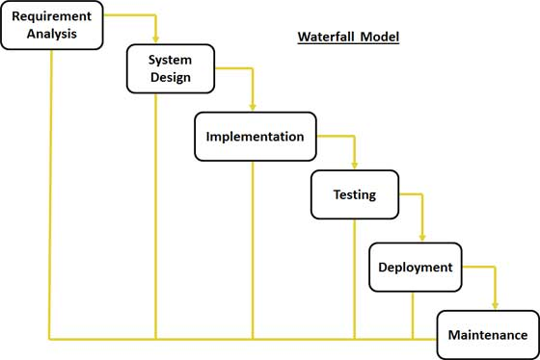

Figure 1: Waterfall Development Model

For more information:

I2EE Book

(Owner tutorialspoint.com. Tutorials Point)

### Roles and responsibilities

|  |  |  |  |
| --- | --- | --- | --- |
| **No** | **Full name** | **Role in Group** | **Responsibilities** |
| **1** | Lai Duc Hung | Project manager | * Specify user requirement * Control the development process * Give out technique and business analysis support |
| **2** | Nguyen Thi Xuan Mai | Team Leader, BA, DEV, Tester | * Managing process * Designing database * Clarifying requirements * Prepare documents * GUI Design * Create test plan * Coding * Testing |
| **3** | Le Minh Hoang | Team Member, BA, DEV, Tester | * Designing database * Clarifying requirements * Prepare documents * GUI Design * Create test plan * Coding * Testing |
| **4** | Nguyen Huu Phuoc | Team Member, BA, DEV, Tester | * Designing database * Clarifying requirements * Prepare documents * GUI Design * Create test plan * Coding * Testing |
| **5** | Ngo Trac Kien | Team Member, BA, DEV, Tester | * Designing database * Clarifying requirements * Prepare documents * GUI Design * Create test plan * Coding * Testing |

Table 4: Roles and Responsibilities Details

### Tools and Techniques

- Front-end technologies: HTML5, CSS3, JavaScript, jQuery, AJAX.

- Back-end: Website: Website: NetBeans IDE 7.4 JDK 1.7.

- Web Server: Microsoft IIS.

- Database Management System: MS SQL Server 2008 Enterprise R2.

## Project Management Plan

### Software Development Life Cycle

|  |  |  |  |  |  |
| --- | --- | --- | --- | --- | --- |
| **Phase** | **Description** | **Deliverables** | **Resource needed** | **Dependencies and Constrains** | **Risks** |
| **Preliminary Investigation or Analysis** | - Collect requirements from customer.  - Identify and clarify requirements for the system in general. | - Introduction of proposed system.  - Software requirement specification  - Project Task Plan.  - Prototypes. | 20 man-days | N/A | - Missing requirement- Unclear scope of project.  - Lack of member share of understand. |
| **Design** | - Architecture design for the system.  - Detail design using top-down.  - Choose Architecture style. | - Software Design Document  - Base code structure. | 20 man-days | Depend on “Requirement Analysis”. | - Lack of experience.  - Not fulfil requirement |
| **Implementation** | - Coding system core functions and other feature with GUI.  - Unit test | - Main user’s functions on web. | 40 man-days | Depend on “Design”. | - Lack of experience and knowledge.  - Human’s mistake. |
| **Testing** | - Integration test the system.  - Alpha test.  - Correct bugs.  - Beta test.  - Acceptance test. | - Test document. | 20 man-days | Depend on “Implementation”. | - Lack of experience.  - Missing test case. |
| **Deployment** | N/A | - Installation guide.  - User Manual. | 10 man-days | Depend on “Testing”. | - Lack of experience. |
| **Maintenance** | N/A | N/A | N/A | N/A | N/A |

Table 5: Development Phases

### Phase Detail

#### Phase 1: Requirement Analysis

|  |  |  |
| --- | --- | --- |
| **Task** | **Description** | **Author** |
| **1. Collect requirements** | Find which systems currently provide similar service, their strengths and weakness. | MaiNTX, HoangLM, PhuocNH, KienNT |
| **2. Identify and clarify main functions** | Define which main functions system should provide. | MaiNTX, HoangLM, PhuocNH, KienNT |
| **3.** **Create System Introduction** | Complete Introduction Report. | MaiNTX |
| **4. Software Project Management Plan** | Prepare Project Management Plan. | MaiNTX |
| **5. Prototype** | Build a prototype of proposed system (Website). | MaiNTX, HoangLM, PhuocNH, KienNT |
| **6. SRS** | Create SRS document. | MaiNTX, HoangLM, PhuocNH, KienNT |

Table 6: Phase 1: Requirement Analysis

#### Phase 2: Design

|  |  |  |
| --- | --- | --- |
| **Task** | **Description** | **Author** |
| **1. Detailed Design** | Which feature this function should have and how to implement. | MaiNTX, HoangLM, PhuocNH, KienNT |
| **2. Database Design** | Design a database which contains all entities information. | MaiNTX, HoangLM, PhuocNH, KienNT |
| **3. Design Document** | Create software design document. | MaiNTX, HoangLM, PhuocNH, KienNT |

Table 7: Phase 2: Design

#### Phase 3: Implementation

|  |  |  |
| --- | --- | --- |
| **Task** | **Description** | **Author** |
| **1. Front-end web functions** | Implement front-end functions on web. | MaiNTX, HoangLM, PhuocNH, KienNT |
| **2. Back-end web functions** | Implement back-end functions on web. | MaiNTX, HoangLM, PhuocNH, KienNT |
| **3. Unit testing** | Write test case and testing for web functions. | MaiNTX, HoangLM, PhuocNH, KienNT |

Table 8: Phase 3: Implementation

#### Phase 4: Testing

|  |  |  |
| --- | --- | --- |
| **Task** | **Description** | **Author** |
| **1. Integration testing** | Write test case and testing systems. | MaiNTX, HoangLM, PhuocNH, KienNT |
| **2. Alpha testing** | Do alpha test with customer. | MaiNTX, HoangLM, PhuocNH, KienNT |

Table 9: Phase 4: Testing

#### Phase 5: Deployment

|  |  |  |
| --- | --- | --- |
| **Task** | **Description** | **Author** |
| **1. Installation guide** | Write installation guide. | MaiNTX |
| **2. User Manual** | Write user manual. | HoangLM, PhuocNH, KienNT |

Table 10: Phase 5: Deployment

#### Phase 6: Maintenance

N/A

### All Meeting Minutes

Refer to Meeting Minutes folder.

## Coding Convention

Use Java coding convention to develop website.

Summary:

* Naming Convention.
  + Use camel case for both variable and function name.
  + Use Pascal case for class name.
* Indentation.
  + Avoid lines longer than 80 characters, since they are not handled well by many terminals and tools.
* Declaration.
  + One declaration per line is recommended since it encourages commenting.
  + In absolutely no case should variables and functions be declared on the same line.
  + Do not put different types on the same line.
* Code Examples

Follow “Code Conventions for the Java TM Programming Language, by Sun Microsystems, rev April 20, 1999”.

<http://www.oracle.com/technetwork/java/codeconventions-150003.pdf>

# Report No. 3 Software Requirement Specification

## User Requirement Specification

### Guest Requirement

Guest is a person who does not have access to the system. The function guest can use following functions:

* Login.

### Engineer Requirement

Engineer is a person who have access to the system. Engineer can use these following functions:

* Search projects.
* View projects detail.
* View evaluation.
* View appraisal.
* Write timesheet.
* Edit timesheet.
* Remove timesheet.
* Edit Profile.
* Search knowledge.
* View knowledge detail.
* Edit knowledge.
* Comment knowledge.
* Edit comment.
* Remove comment.
* Search timesheets.

### Manager Requirement

Manager is a person who have access to the system. Manager can use these following functions:

* Assign engineers to project
* Remove engineers from project
* Search employees
* View employee profile.
* Review timesheets.
* Appraise project engineers.
* Edit appraisal.
* Evaluate engineers in period time
* Edit evaluation.

### Director Requirement

Director is a person who have access to the system. Director can use these following functions:

* Create project.
* Edit project.
* Review assigned engineers.
* Review evaluation.
* Search recruitment
* View recruitment detail.
* Create recruitment
* Edit recruitment.
* Reply recruitment.

### Customer Requirement

Customer is a person who have access to the system. Customer can use these following functions:

* Make feedback.

### Admin Requirement

Admin is the person who manages the system. Admin is can use these following function:

* Search account.
* View account.
* Create account.
* Edit account.
* Add criterion.
* Edit criterion.
* Remove criterion.
* Create period evaluation.
* Edit period evaluation.
* Remove period evaluation.

### HR Person Requirement

HR is a person who have access to the system. HR can use these following functions:

* Search recruitment
* View recruitment detail.
* Reply recruitment.

## System Requirement Specification

### External Interface Requirement

#### User Interface

* General requirement for graphics user interface is the GUI should be simple, clear, intuitive, and reminiscent.
* The interface design is an iterate process includes design, sketching, prototyping, user assessment.
* Some design principles will be taken into consideration:
  + UI for business web applications - Janko Jovanovic [Ref: <http://www.smashingmagazine.com/2010/02/25/designing-user-interfaces-for-business-web-applications/>]
  + Ten principles of effective web design – Vitaly Friedman [Ref: <http://www.smashingmagazine.com/2008/01/31/10-principles-of-effective-web-design/>]
  + Principles of mobile interface design – Jonathan Stark [Ref: <http://www.oreilly.com/pub/e/2144>]

#### Hardware Interface

* N/A

#### Software Interface

* Run with Fire Fox (version 37.0.1), Chrome (version 42.0.2311.90 m) browser and must support Java script and HTML5.

#### Communication Protocol

* Using HTTP/HTTPS protocol

### System Overview Use Case



Figure 2: System Overview Use Case



### List of Use Case

#### <Guest> Overview Use Case



**Figure 3: <Guest> Overview Use Case**



##### <Guest> Login Use Case Diagram



**Figure 4: <Guest> Login use case diagram**

**Use Case Specification**

#### <Engineer> Overview Use Case



**Figure 5: <Engineer> Overview Use Case**

##### <Engineer> Search Timesheets Use Case Diagram



**Figure 6: < Engineer > Search Timesheets Use Case Diagram**

**Use Case Specification**

##### <Engineer> Write Timesheet Use Case Diagram



**Figure 7: <Engineer> Write Timesheet Use Case Diagram**

**Use Case Specification**

##### <Engineer> Edit Timesheet Status Use Case Diagram



**Figure 8: <Engineer> Edit Timesheet Status Use Case Diagram**

**Use Case Specification**

##### <Engineer> Remove Timesheet Use Case Diagram



**Figure 9: <Engineer> Remove Timesheet Use Case Diagram**

**Use Case Specification**

##### <Engineer> Logout Use Case Diagram



**Figure 10: <Engineer> Logout Use Case Diagram**

**Use Case Specification**

##### <Engineer> View Evaluation Use Case Diagram



**Figure 11: <Engineer> View Evaluation Use Case Diagram**

**Use Case Specification**

##### <Engineer> View Appraisal Status Use Case Diagram



**Figure 12: <Engineer> View Appraisal Status Use Case Diagram**

**Use Case Specification**

##### <Engineer> Edit Profile Use Case Diagram



**Figure 13: <Engineer> Edit Profile Status Use Case Diagram**

##### <Engineer> View Knowledge Detail Use Case Diagram



**Figure 14: <Engineer> View Knowledge Detail Use Case Diagram**

**Use Case Specification**

##### <Engineer> Add Knowledge Use Case Diagram



**Figure 15: <Engineer> Add Knowledge Use Case Diagram**

**Use Case Specification**

##### <Engineer> Edit Knowledge Use Case Diagram



**Figure 16: <Engineer> Edit Knowledge Use Case Diagram**

**Use Case Specification**

##### <Engineer> Search Knowledge Use Case Diagram



**Figure 17: <Engineer> Search Knowledge Use Case Diagram**

**Use Case Specification**

##### <Engineer> Add comment Use Case Diagram



**Figure 18: <Engineer> Add Comment Use Case Diagram**

**Use Case Specification**

##### <Engineer> Edit Comment Use Case Diagram



**Figure 19: <Engineer> Edit Comment Use Case Diagram**

**Use Case Specification**

##### <Engineer> Remove Comment Use Case Diagram



**Figure 20: <Engineer> Remove Comment Use Case Diagram**

**Use Case Specification**

##### <Engineer> Search Projects Use Case Diagram



**Figure 21: <Engineer> Search Projects Use Case Diagram**

**Use Case Specification**

##### <Engineer> View Projects Detail Use Case Diagram



**Figure 22: <Engineer> View Projects Detail Use Case Diagram**

**Use Case Specification**

#### <Manager> Overview Use Case



**Figure 23: <Manager> Overview Use Case Diagram**

##### <Manager> View Employee Profile Use Case Diagram



**Figure 24: <Manager> View Employee Profile Use Case Diagram**

**Use Case Specification**

##### <Manager> Search Employee Use Case Diagram



**Figure 25: <Manager> Search Employees Use Case Diagram**

**Use Case Specification**

##### <Manager> Review Timesheets Use Case Diagram



**Figure 26: <Manager> Review Timesheets Use Case Diagram**

**Use Case Specification**

##### <Manager> Appraise Engineers Use Case Diagram



**Figure 27: <Manager> Appraise Engineers Use Case Diagram**

**Use Case Specification**

##### <Manager> Edit Appraisal Use Case Diagram



**Figure 28: <Manager> Edit Appraisal Use Case Diagram**

**Use Case Specification**

##### <Manager> Evaluate Employees Use Case Diagram



**Figure 29: <Manager> Evaluate Employee Use Case Diagram**

**Use Case Specification**

##### <Manager> Edit Evaluation Use Case Diagram



**Figure 30: <Manager> Edit Evaluation Use Case Diagram**

**Use Case Specification**

##### <Employee> Assign Engineers to Project Use Case Diagram



**Figure 31: <Manager> Assign Engineers to Project Use Case Diagram**

**Use Case Specification**

##### <Employee> Remove Engineers from Project Use Case Diagram



**Figure 32: <Manager> Remove Engineers from Project Use Case Diagram**

**Use Case Specification**

#### <Director> Overview Use Case



**Figure 33: <Director> Overview Use Case Diagram**

##### <Director> Create Project Use Case Diagram



**Figure 34: <Director> Create Project Use Case Diagram**

**Use Case Specification**

##### <Director> Edit Project Use Case Diagram



**Figure 35: <Director> Edit Project Use Case Diagram**

**Use Case Specification**

##### <Director> Review Assigned Engineers Use Case Diagram



**Figure 36: <Director> Review Assigned engineers Use Case Diagram**

**Use Case Specification**

##### <Director> Create Recruitment Engineers Use Case Diagram



**Figure 37: <Director> Create Recruitment Use Case Diagram**

**Use Case Specification**

##### <Director> Edit Recruitment Use Case Diagram



**Figure 38: <Director> Edit Recruitment Use Case Diagram**

**Use Case Specification**

##### <Director> Reply Recruitment Use Case Diagram



**Figure 39: <Director> Reply Recruitment Use Case Diagram**

**Use Case Specification**

##### <Director> Search Recruitment Use Case Diagram



**Figure 40: <Director> Search Recruitment Use Case Diagram**

**Use Case Specification**

##### <Director> View Recruitment Detail Use Case Diagram



**Figure 41: <Director> View Recruitment Detail Use Case Diagram**

**Use Case Specification**

##### <Director> Review Evaluation Use Case Diagram



**Figure 42: <Director> Review Evaluation Use Case Diagram**

**Use Case Specification**

#### <Customer> Overview Use Case



**Figure 43: <Customer> Overview Use Case Diagram**

##### <Customer> Make Feedback Project Use Case Diagram



**Figure 44: <Customer> Make Feedback Project Use Case Diagram**

**Use Case Specification**

#### <Admin> Overview Use Case



**Figure 45: <Admin> Overview Use Case Diagram**

##### <Admin> Add Criterion Project Use Case Diagram



**Figure 46: <Admin> Add Criterion Project Use Case Diagram**

**Use Case Specification**

##### <Admin> Edit Criterion Use Case Diagram



**Figure 47: <Admin> Edit Criterion Use Case Diagram**

**Use Case Specification**

##### <Admin> Remove Criterion Use Case Diagram



**Figure 48: <Admin> Remove Criterion Use Case Diagram**

**Use Case Specification**

##### <Admin> Create Period Evaluation Use Case Diagram



**Figure 49: <Admin> Create Period Evaluation Use Case Diagram**

**Use Case Specification**

##### <Admin> Edit Period Evaluation Use Case Diagram



**Figure 50: <Admin> Edit Period Evaluation Use Case Diagram**

**Use Case Specification**

##### <Admin> Remove Period Evaluation Use Case Diagram



**Figure 51: <Admin> Remove Evaluation Use Case Diagram**

**Use Case Specification**

##### <Admin> View Account Use Case Diagram



**Figure 52: <Admin> View Account Project Use Case Diagram**

**Use Case Specification**

##### <Admin> Search Accounts Use Case Diagram



**Figure 53: <Admin> Search Accounts Use Case Diagram**

**Use Case Specification**

##### <Admin> Create Account Use Case Diagram



**Figure 54: <Admin> Create Account Use Case Diagram**

**Use Case Specification**

##### <Admin> Edit Account Use Case Diagram



**Figure 55: <Admin> Edit Account Use Case Diagram**

**Use Case Specification**

#### <HR> Overview Use Case



**Figure 56: <HR> Overview Use Case Diagram**

##### <HR> Reply Recruitment Use Case Diagram



**Figure 57: <HR> Reply Recruitment Use Case Diagram**

**Use Case Specification**

##### <HR> Search Recruitment Use Case Diagram



**Figure 58: <HR> Search Recruitment**

**Use Case Specification**

##### <HR> View Recruitment Detail Use Case Diagram



**Figure 59: <HR> View Recruitment Detail Use Case Diagram**

**Use Case Specification**

## Software System Attribute

### Usability

#### Graphic User Interface

* + All the texts, labels and should be written in English.

#### Usability

* + Admin only need one day of training to use this system.

#### Installation

* + The system must be easy to deploy. Employees can deploy successfully and learn to configure, maintain the system within one day of training.
  + The attached manual guide must be clear. User can read and do themselves without developer’s help.

### Reliability

* + Personal information about order of Employees can be backup and restore easily using import/export function.

### Availability

* + User need to have an internet connection to use every function of the system in the best way.

### Security

* + Information about employee only can be view by their own or be view with limitation by others. Even Admin cannot do everything to account’s information.

### Maintainability

* + The system is divided into separated modules.

### Portability

* + The system can be deployed into many type of servers those have Tomcat server.

### Performance

## Conceptual Diagram

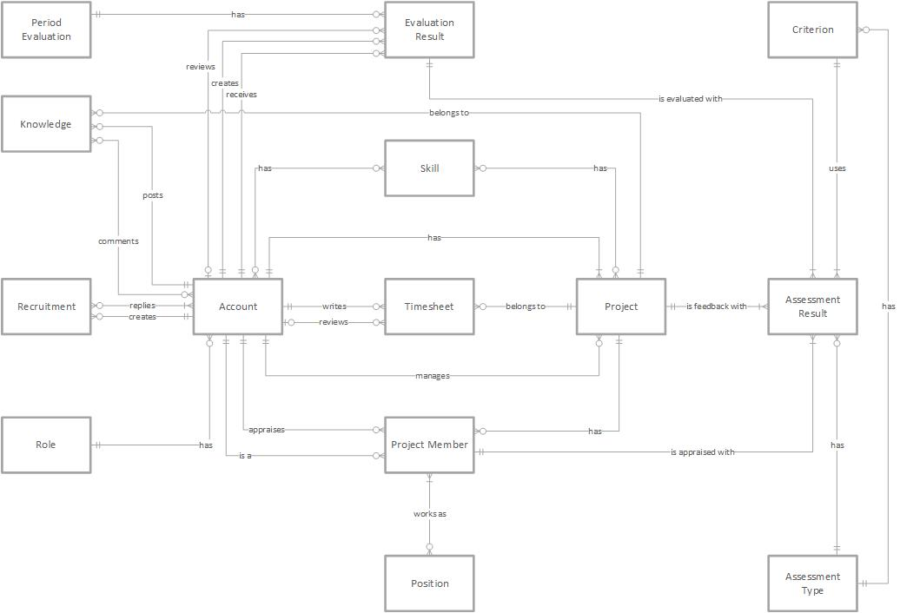

**Data Dictionary**

|  |  |
| --- | --- |
| **Entity Data dictionary: describe content of all entities** | |
| Entity Name | Description |
| Period Evaluation | Describe all Period Evaluations in the system. |
| Evaluation Result | Describe all Evaluation Results in the system. |
| Criterion | Describe all Criterions available in the system. |
| Knowledge | Describe all Knowledge in the system. |
| Skills | Describe all Skills in the system. |
| Account | Describe all Accounts in the system. |
| Timesheet | Describe all Timesheets in the system. |
| Project | Describe all Projects in the system. |
| Assessment Result | Describe all Assessment Results in the system. |
| Role | Describe all Roles in the system. |
| Project Member | Describe all Project Members in the system. |
| Position | Describe all Positions in the system. |
| Assessment Type | Describe all Assessment Types in the system. |

# Report No. 4 Software Design Description

## Design Overview

* This document describes the technical and user interface design of EPS System. It includes the architectural design, the detailed design of common functions and business functions and the design of database model.
* The architectural design describes the overall architecture of the system and the architecture of each main component and subsystem.
* The detailed design describes static and dynamic structure for each component and functions. It includes class diagrams, class explanations and sequence diagrams for each use cases.
* The database design describes the relationships between entities and details of each entity.
* Document overview:
* Section 2: gives an overall description of the system architecture design.
* Section 3: gives component diagrams that describe the connection and integration of the system.
* Section 4: gives the detail design description, which includes class diagram, class explanation, and sequence diagram to details the application functions.
* Section 5: describe a fully attributed ERD.

## System Architectural Design

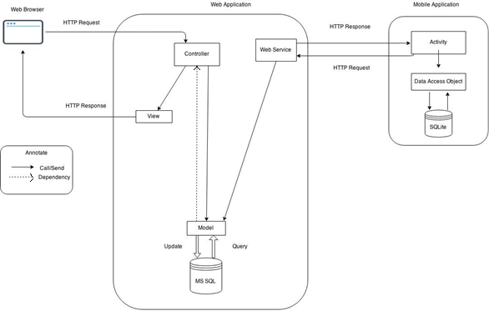

Figure 4: EPS System Architectural



#### Web application architecture description

* The system is developed from MVC architecture style and customized with passive model to adapt to JAVA MVC, RESTful web service technologies.
* **Model** is a part of application which uses to storage and retrieval data.
* **View** is the part of the application that visualizes the data to help user easily to view, update or customize them.
* **Controller** is the parts of the application that acts like event handler to handles user interaction. Typically controller read data from a request and returns respective view for user.
* **Web Service** is the parts of the application which use to provide interface for mobile application to do some background operation such as download template, convert excel file...

## Component Diagram

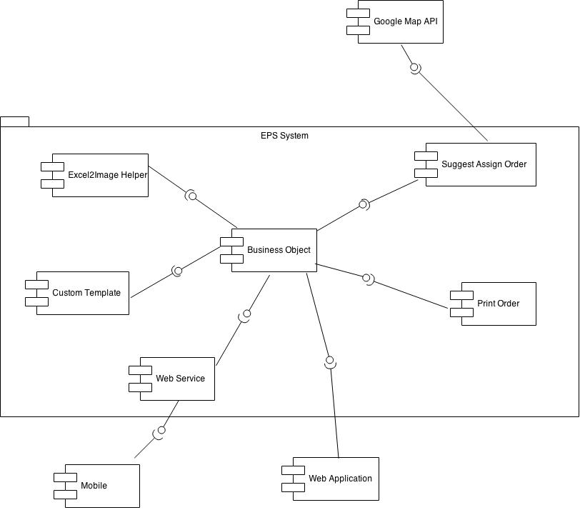

Figure 4: Conceptual Diagram

|  |  |
| --- | --- |
| **Component dictionary: describe component** | |
| Component Name | Description |
| Business Object | Handle business process. |
| Excel2Html Helper | Handle process of create a printable order, using XSSF Helper library from Apache POI and Html2Image library.  *Html2Image*  *( https://code.google.com/p/java-html2image/ )*  *XSSFHtmlHelper (http://svn.apache.org/repos/asf/poi/trunk/src/examples/*  *src/org/apache/poi/ss/examples/html/)* |
| Web Service | Content all web service of the system. |
| Custom Template | Handle the process of create and customize template. |
| Suggest Assign Order | Use to make suggest for StoreOwner to assign order for their Employee. |
| Print Order | Handle the process of printing order. |
| Google Map API | Use to work with Google Map API to get input data for Suggest Assign Order. |
| Mobile | Android Application. |
| Web Application | Web Application |

## Detailed Description

### Class Diagram



Figure 2: Class Diagram

### Class Diagram Explanation

#### Account

Attribute

|  |  |  |  |
| --- | --- | --- | --- |
| **Attribute** | **Type** | **Visibility** | **Description** |
| StoreOwnerId | int | Private | Unique identifier of a storeowner |
| UserName | String | Private | Username of storeowner |
| Email | String | Private | Email of storeowner |
| Password | String | Private | Password of storeowner |
| Website | String | Private | Website address of storeowner |
| StoreName | String | Private | Name of the store |
| Address | String | Private | Address of the store |
| FullName | String | Private | Full name of storeowner |
| PhoneNumber | String | Private | Phone number of storeowner |
| isFirstUse | boolean | Private | Value to check whether storeowner log in for the first time or not |
| Status | String | Private | Status of storeowner |

Method

|  |  |  |  |
| --- | --- | --- | --- |
| **Method** | **Return type** | **Visibility** | **Description** |
| Getter | Attribute type | Public | Get attribute value |
| Setter | Void | Public | Set value of attribute |

#### Role

Attribute

|  |  |  |  |
| --- | --- | --- | --- |
| **Attribute** | **Type** | **Visibility** | **Description** |
| Id | int | Private | Unique identifier of an employee |
| UserName | String | Private | Username of employee |
| Password | String | Private | Password of employee |
| FullName | String | Private | Full name of employee |
| StoreOwnerId | int | Private | Id of storeowner |
| Status | String | Private | Status of an employee |

Method

|  |  |  |  |
| --- | --- | --- | --- |
| **Method** | **Return type** | **Visibility** | **Description** |
| Getter | Attribute type | Public | Get attribute value |
| Setter | Void | Public | Set value of attribute |

#### Project

Attribute

|  |  |  |  |
| --- | --- | --- | --- |
| **Attribute** | **Type** | **Visibility** | **Description** |
| ItemId | int | Private | Unique identifier of an item |
| ItemName | String | Private | Name of an item |
| ItemDescription | String | Private | Description about item |
| SupplyPrice | float | Private | Supply price of item |
| RetailPrice | float | Private | Retail price of item |
| ItemType | String | Private | Type of item |
| Unit | String | Private | Calculating unit of item |
| Quantity | int | Private | Quantity of item in store |
| StoreOwnerId | int | Private | Id of storeowner |
| Status | String | Private | Status of an item |

Method

|  |  |  |  |
| --- | --- | --- | --- |
| **Method** | **Return type** | **Visibility** | **Description** |
| Getter | Attribute type | Public | Get attribute value |
| Setter | Void | Public | Set value of attribute |

#### Project Member

Attribute

|  |  |  |  |
| --- | --- | --- | --- |
| **Attribute** | **Type** | **Visibility** | **Description** |
| TemplateId | int | Private | Unique identifier of a template |
| TemplateName | String | Private | Name of template |
| TemplateLocation | String | Private | Location of template on server |
| TemplateImageLocation | String | Private | Location of template’s image on server |
| OwnerId | int | Private | Id of template’s owner |
| Status | String | Private | Status of template |
| Type | String | Private | Type of template |
| isDefault | boolean | Private | Value to check whether template is a default template or not |

Method

|  |  |  |  |
| --- | --- | --- | --- |
| **Method** | **Return type** | **Visibility** | **Description** |
| Getter | Attribute type | Public | Get attribute value |
| Setter | Void | Public | Set value of attribute |

#### Working Tracking

Attribute

|  |  |  |  |
| --- | --- | --- | --- |
| **Attribute** | **Type** | **Visibility** | **Description** |
| OrderId | int | Private | Unique identifier of an order |
| TotalPrice | float | Private | Total price of order |
| Date | String | Private | Date order was created |
| CustomerName | String | Private | Name of customer |
| Address | String | Private | Address of customer |
| AddressLat_Long | String | Private | Latitude and longitude of customer’s address |
| StoreOwnerId | int | Private | Id of storeowner |
| isPrinted | boolean | Private | Value to check whether order is a printed or not |

Method

|  |  |  |  |
| --- | --- | --- | --- |
| **Method** | **Return type** | **Visibility** | **Description** |
| Getter | Attribute type | Public | Get attribute value |
| Setter | Void | Public | Set value of attribute |

#### Position

Attribute

|  |  |  |  |
| --- | --- | --- | --- |
| **Attribute** | **Type** | **Visibility** | **Description** |
| OrderDetailId | int | Private | Unique identifier of an order detail |
| ItemPrice | float | Private | Price of an item |
| OrderId | int | Private | Id of order |
| ItemId | int | Private | Id of item |
| Quantity | Int | Private | Number of item |

Method

|  |  |  |  |
| --- | --- | --- | --- |
| **Method** | **Return type** | **Visibility** | **Description** |
| Getter | Attribute type | Public | Get attribute value |
| Setter | Void | Public | Set value of attribute |

#### Skill

Attribute

|  |  |  |  |
| --- | --- | --- | --- |
| **Attribute** | **Type** | **Visibility** | **Description** |
| NotificationId | int | Private | Unique identifier of notification |
| AssignStatus | boolean | Private | Status of order assigned to employee |
| NofiticationStatus | boolean | Private | Status of notification |
| EmployeeId | int | Private | Id of employee |

Method

|  |  |  |  |
| --- | --- | --- | --- |
| **Method** | **Return type** | **Visibility** | **Description** |
| Getter | Attribute type | Public | Get attribute value |
| Setter | Void | Public | Set value of attribute |

#### Project Skill

Attribute

|  |  |  |  |
| --- | --- | --- | --- |
| **Attribute** | **Type** | **Visibility** | **Description** |
| OrderId | int | Private | Id of order |
| EmployeeId | int | Private | Id of employee |
| isReceived | boolean | Private | Value to check whether order is a received or not |

Method

|  |  |  |  |
| --- | --- | --- | --- |
| **Method** | **Return type** | **Visibility** | **Description** |
| Getter | Attribute type | Public | Get attribute value |
| Setter | Void | Public | Set value of attribute |

#### Engineer Skill

Attribute

|  |  |  |  |
| --- | --- | --- | --- |
| **Attribute** | **Type** | **Visibility** | **Description** |
| AdminId | int | Private | Unique identifier of admin |
| UserName | String | Private | Username of admin |
| Password | String | Private | Password of admin |

Method

|  |  |  |  |
| --- | --- | --- | --- |
| **Method** | **Return type** | **Visibility** | **Description** |
| Getter | Attribute type | Public | Get attribute value |
| Setter | Void | Public | Set value of attribute |

#### Criterion

|  |  |  |  |
| --- | --- | --- | --- |
| **Attribute** | **Type** | **Visibility** | **Description** |
| AdminId | int | Private | Unique identifier of admin |
| UserName | String | Private | Username of admin |
| Password | String | Private | Password of admin |

Method

|  |  |  |  |
| --- | --- | --- | --- |
| **Method** | **Return type** | **Visibility** | **Description** |
| Combination | String Array | Public | Calculation combination of medoid |
| KMedoids | 2-Dementions String Array | Public | Implement Kmedoid algorithm. |

#### Assessment Type

|  |  |  |  |
| --- | --- | --- | --- |
| **Attribute** | **Type** | **Visibility** | **Description** |
| AdminId | int | Private | Unique identifier of admin |
| UserName | String | Private | Username of admin |
| Password | String | Private | Password of admin |

Method

|  |  |  |  |
| --- | --- | --- | --- |
| **Method** | **Return type** | **Visibility** | **Description** |
| Combination | String Array | Public | Calculation combination of medoid |
| KMedoids | 2-Dementions String Array | Public | Implement Kmedoid algorithm. |

#### Assessment Result

|  |  |  |  |
| --- | --- | --- | --- |
| **Attribute** | **Type** | **Visibility** | **Description** |
| AdminId | int | Private | Unique identifier of admin |
| UserName | String | Private | Username of admin |
| Password | String | Private | Password of admin |

Method

|  |  |  |  |
| --- | --- | --- | --- |
| **Method** | **Return type** | **Visibility** | **Description** |
| Combination | String Array | Public | Calculation combination of medoid |
| KMedoids | 2-Dementions String Array | Public | Implement Kmedoid algorithm. |

#### Period Evaluation

|  |  |  |  |
| --- | --- | --- | --- |
| **Attribute** | **Type** | **Visibility** | **Description** |
| AdminId | int | Private | Unique identifier of admin |
| UserName | String | Private | Username of admin |
| Password | String | Private | Password of admin |

Method

|  |  |  |  |
| --- | --- | --- | --- |
| **Method** | **Return type** | **Visibility** | **Description** |
| Combination | String Array | Public | Calculation combination of medoid |
| KMedoids | 2-Dementions String Array | Public | Implement Kmedoid algorithm. |

#### Evaluation Result

|  |  |  |  |
| --- | --- | --- | --- |
| **Attribute** | **Type** | **Visibility** | **Description** |
| AdminId | int | Private | Unique identifier of admin |
| UserName | String | Private | Username of admin |
| Password | String | Private | Password of admin |

Method

|  |  |  |  |
| --- | --- | --- | --- |
| **Method** | **Return type** | **Visibility** | **Description** |
| Combination | String Array | Public | Calculation combination of medoid |
| KMedoids | 2-Dementions String Array | Public | Implement Kmedoid algorithm. |

#### Timesheet

|  |  |  |  |
| --- | --- | --- | --- |
| **Attribute** | **Type** | **Visibility** | **Description** |
| AdminId | int | Private | Unique identifier of admin |
| UserName | String | Private | Username of admin |
| Password | String | Private | Password of admin |

Method

|  |  |  |  |
| --- | --- | --- | --- |
| **Method** | **Return type** | **Visibility** | **Description** |
| Combination | String Array | Public | Calculation combination of medoid |
| KMedoids | 2-Dementions String Array | Public | Implement Kmedoid algorithm. |

#### Knowledge

|  |  |  |  |
| --- | --- | --- | --- |
| **Attribute** | **Type** | **Visibility** | **Description** |
| AdminId | int | Private | Unique identifier of admin |
| UserName | String | Private | Username of admin |
| Password | String | Private | Password of admin |

Method

|  |  |  |  |
| --- | --- | --- | --- |
| **Method** | **Return type** | **Visibility** | **Description** |
| Combination | String Array | Public | Calculation combination of medoid |
| KMedoids | 2-Dementions String Array | Public | Implement Kmedoid algorithm. |

#### Comment

|  |  |  |  |
| --- | --- | --- | --- |
| **Attribute** | **Type** | **Visibility** | **Description** |
| AdminId | int | Private | Unique identifier of admin |
| UserName | String | Private | Username of admin |
| Password | String | Private | Password of admin |

Method

|  |  |  |  |
| --- | --- | --- | --- |
| **Method** | **Return type** | **Visibility** | **Description** |
| Combination | String Array | Public | Calculation combination of medoid |
| KMedoids | 2-Dementions String Array | Public | Implement Kmedoid algorithm. |

#### Recruitment

|  |  |  |  |
| --- | --- | --- | --- |
| **Attribute** | **Type** | **Visibility** | **Description** |
| AdminId | int | Private | Unique identifier of admin |
| UserName | String | Private | Username of admin |
| Password | String | Private | Password of admin |

Method

|  |  |  |  |
| --- | --- | --- | --- |
| **Method** | **Return type** | **Visibility** | **Description** |
| Combination | String Array | Public | Calculation combination of medoid |
| KMedoids | 2-Dementions String Array | Public | Implement Kmedoid algorithm. |

#### Recruitment Reply

|  |  |  |  |
| --- | --- | --- | --- |
| **Attribute** | **Type** | **Visibility** | **Description** |
| AdminId | int | Private | Unique identifier of admin |
| UserName | String | Private | Username of admin |
| Password | String | Private | Password of admin |

Method

|  |  |  |  |
| --- | --- | --- | --- |
| **Method** | **Return type** | **Visibility** | **Description** |
| Combination | String Array | Public | Calculation combination of medoid |
| KMedoids | 2-Dementions String Array | Public | Implement Kmedoid algorithm. |

### Sequence Diagram

##### <Guest> Login

**Summary:** This diagram shows how to guest login as Engineer, Manager, Director, Customer, Admin, HR.

Figure 29: <Guest> Login

##### <Engineer> Logout

**Summary:** This diagram shows how to…...

Figure 30: <Engineer> Logout

##### <Engineer> Search Timesheets

**Summary:** This diagram shows how to…...

Figure 30: <Engineer> Search Timesheets

##### <Engineer> Write Timesheets

**Summary:** This diagram shows how to…...

Figure 30: <Engineer> Write Timesheets

##### <Engineer> Search Timesheets

**Summary:** This diagram shows how to…...

Figure 30: <Engineer> Search Timesheets

##### <Engineer> Edit Timesheets

**Summary:** This diagram shows how to…...

Figure 30: <Engineer> Edit Timesheets

##### <Engineer> Remove Timesheets

**Summary:** This diagram shows how to…...

Figure 30: <Engineer> Remove Timesheets

##### <Engineer> View Evaluation

**Summary:** This diagram shows how to…...

Figure 30: <Engineer> View Evaluation

##### <Engineer> View Appraisal

**Summary:** This diagram shows how to…...

Figure 30: <Engineer> View Appraisal

##### <Engineer> Edit Profile

**Summary:** This diagram shows how to…...

Figure 30: <Engineer> Edit Profile

##### <Engineer> View Knowledge Detail

**Summary:** This diagram shows how to…...

Figure 30: <Engineer> View Knowledge Detail

##### <Engineer> Add Knowledge

**Summary:** This diagram shows how to…...

Figure 30: <Engineer>Add Knowledge

##### <Engineer> Search Knowledges

**Summary:** This diagram shows how to…...

Figure 30: <Engineer> Search Knowledges

##### <Engineer> Add Comment

**Summary:** This diagram shows how to…...

Figure 30: <Engineer> Add Comment

##### <Engineer> Edit Comment

**Summary:** This diagram shows how to…...

Figure 30: <Engineer> Edit Comment

##### <Engineer> Remove Comment

**Summary:** This diagram shows how to…...

Figure 30: <Engineer> Remove Comment

##### <Engineer> Search Projects

**Summary:** This diagram shows how to…...

Figure 30: <Engineer> Search Projects

##### <Engineer> View Project Detail

**Summary:** This diagram shows how to…...

Figure 30: <Engineer> View Project Detail

### Activity Diagram

#### <Employee> Get Assigned Order

**Summary:** This diagram shows how Employee gets orders, which assigned for them.

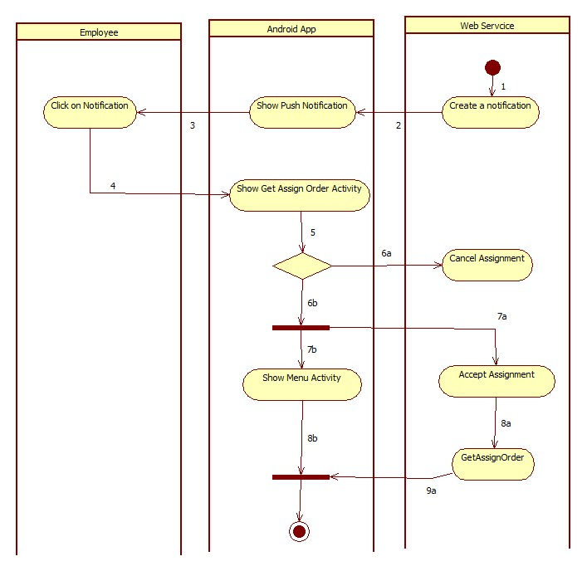

|  |  |  |  |
| --- | --- | --- | --- |
| 1. Start | 2. Call Parse.com API to push the notification to employee’s phone | 3.Show notification | 4. Employee clicks to view notification’s info |
| 5. Employee response to the notification | 6a. Employee cancel assignment | 6b. Employee accept assignment | 7a. Response accept message to server. |
| 7b. Start Activity | 8a. Call GetAssignOrder() | 9a. Response order’s detail |  |

Figure 48: <Employee> Get Assigned Order

#### <Employee> Create Order

**Summary:** This diagram shows how Employee creates a new order on Android phone.

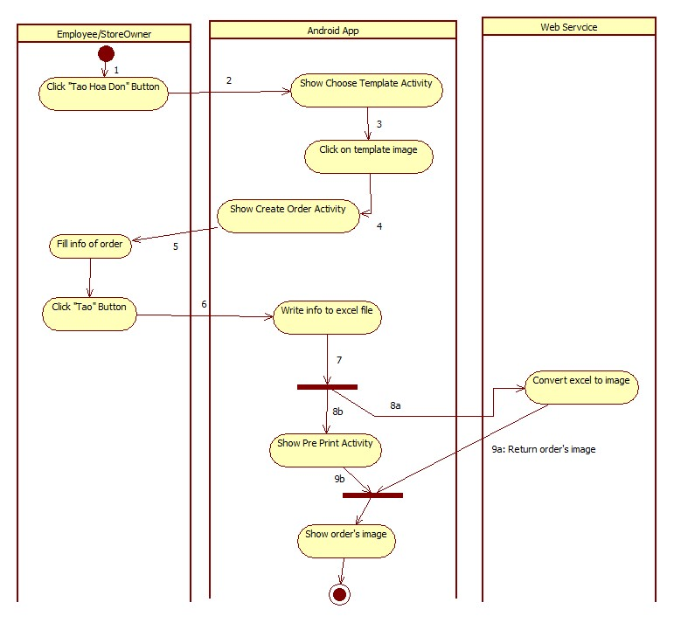

|  |  |  |
| --- | --- | --- |
| 1. Start | 2. Start Activity | 3. Employee select template |
| 4. Start Activity | 5.Employee fill info of order | 6. Click on “Tạo” button to create order. |
| 8a. Call API to convert excel file to image | 8b. Start Activity | 9a. Return Order’s image. |

Figure 49: <Employee> Create Order

#### <Employee> Print Order

**Summary:** This diagram shows how Employee prints a order.

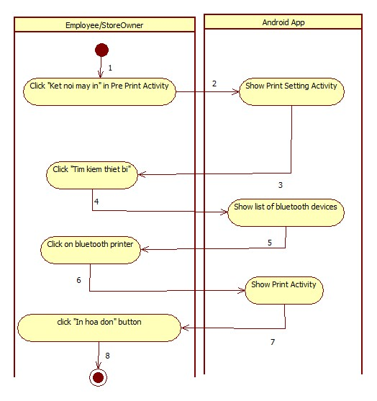

|  |  |  |
| --- | --- | --- |
| 1. Start | 2. Start Activity | 3. Employee find Bluetooth printer. |
| 4. Get search result | 5. Clicks on suitable device | 6. Start Activity |
| 7. Input Number of copy | 8.Finish |  |

Figure 50: <Employee> Print Order

## User Interface Design

### Admin Interface Design

#### Admin Login

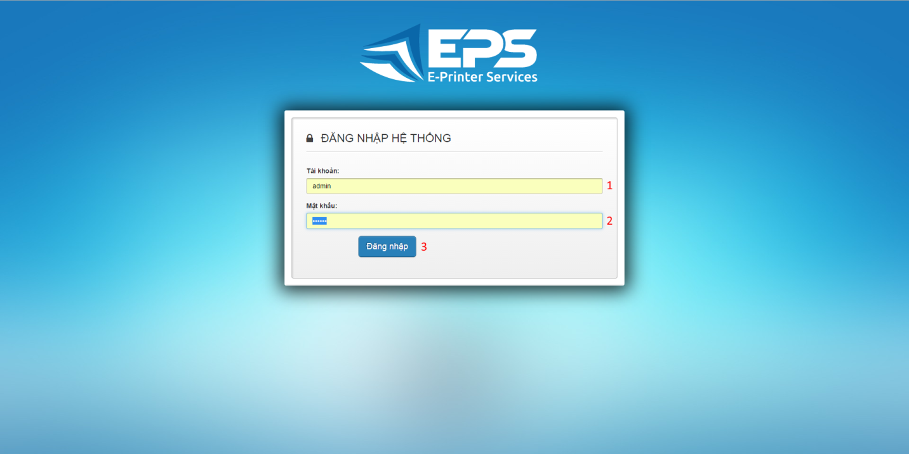

Figure 1: Admin Login

**Fields**

|  |  |  |  |  |  |  |  |
| --- | --- | --- | --- | --- | --- | --- | --- |
| **No** | **Field Name** | **Description** | **Read only** | **Mandatory** | **Control Type** | **Data Type** | **Length** |
| 1 | Username | Fill user name | No | Yes | Textbox | String | N/A |
| 2 | Password | Fill password | No | Yes | Password | String | N/A |

**Buttons/Hyperlinks**

|  |  |  |  |  |
| --- | --- | --- | --- | --- |
| **No** | **Function** | **Description** | **Validation** | **Outcome** |
| 3 | Sign in | Log-in into the system | N/A | Transfer to admin home page |

#### Admin Manage Templates

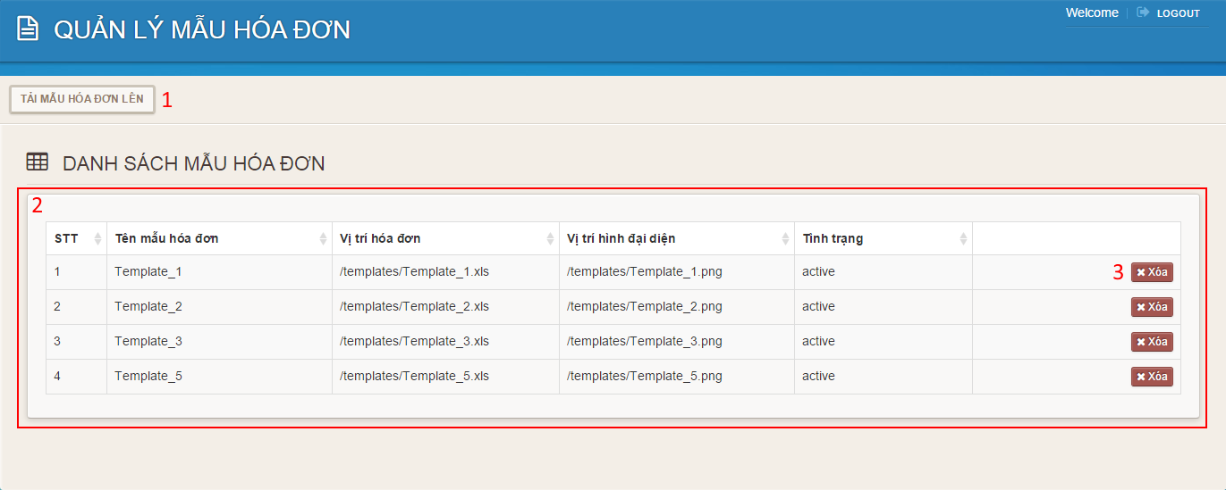

Figure 2: Admin Manage Templates

**Fields**

|  |  |  |  |  |  |  |  |
| --- | --- | --- | --- | --- | --- | --- | --- |
| **No** | **Field Name** | **Description** | **Read only** | **Mandatory** | **Control Type** | **Data Type** | **Length** |
| 2 | Template’s table | Table to show templates | Yes | N/A | Data Table | N/A | N/A |

**Buttons/Hyperlinks**

|  |  |  |  |  |
| --- | --- | --- | --- | --- |
| **No** | **Function** | **Description** | **Validation** | **Outcome** |
| 1 | Upload Template | Click to go to upload template page. | N/A | Transfer to upload template page. |
| 3 | Delete | Delete template | N/A | Delete a template |

#### Admin Upload Template

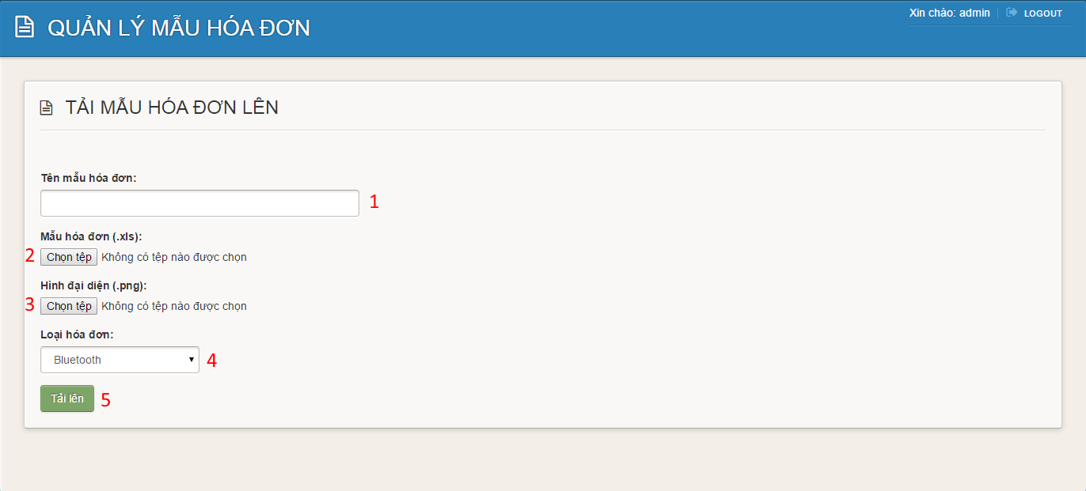**Figure 3: Admin Upload Template**

**Fields**

|  |  |  |  |  |  |  |  |
| --- | --- | --- | --- | --- | --- | --- | --- |
| **No** | **Field Name** | **Description** | **Read only** | **Mandatory** | **Control Type** | **Data Type** | **Length** |
| 1 | Template’s name | Fill template’s name | No | Yes | Textbox | String | N/A |
| 4 | Template’s type | Choose template’s type | No | Yes | Comboxbox | String | N/A |

**Buttons/Hyperlinks**

|  |  |  |  |  |
| --- | --- | --- | --- | --- |
| **No** | **Function** | **Description** | **Validation** | **Outcome** |
| 2 | Choose .xls file | Click to go to choose file dialog | N/A | Display choose file dialog |
| 3 | Choose .png file | Click to go to choose file dialog | N/A | Display choose file dialog |
| 5 | Upload template | Click to upload template | N/A | Transfer to manage template page |

#### Admin Manage Storeowners

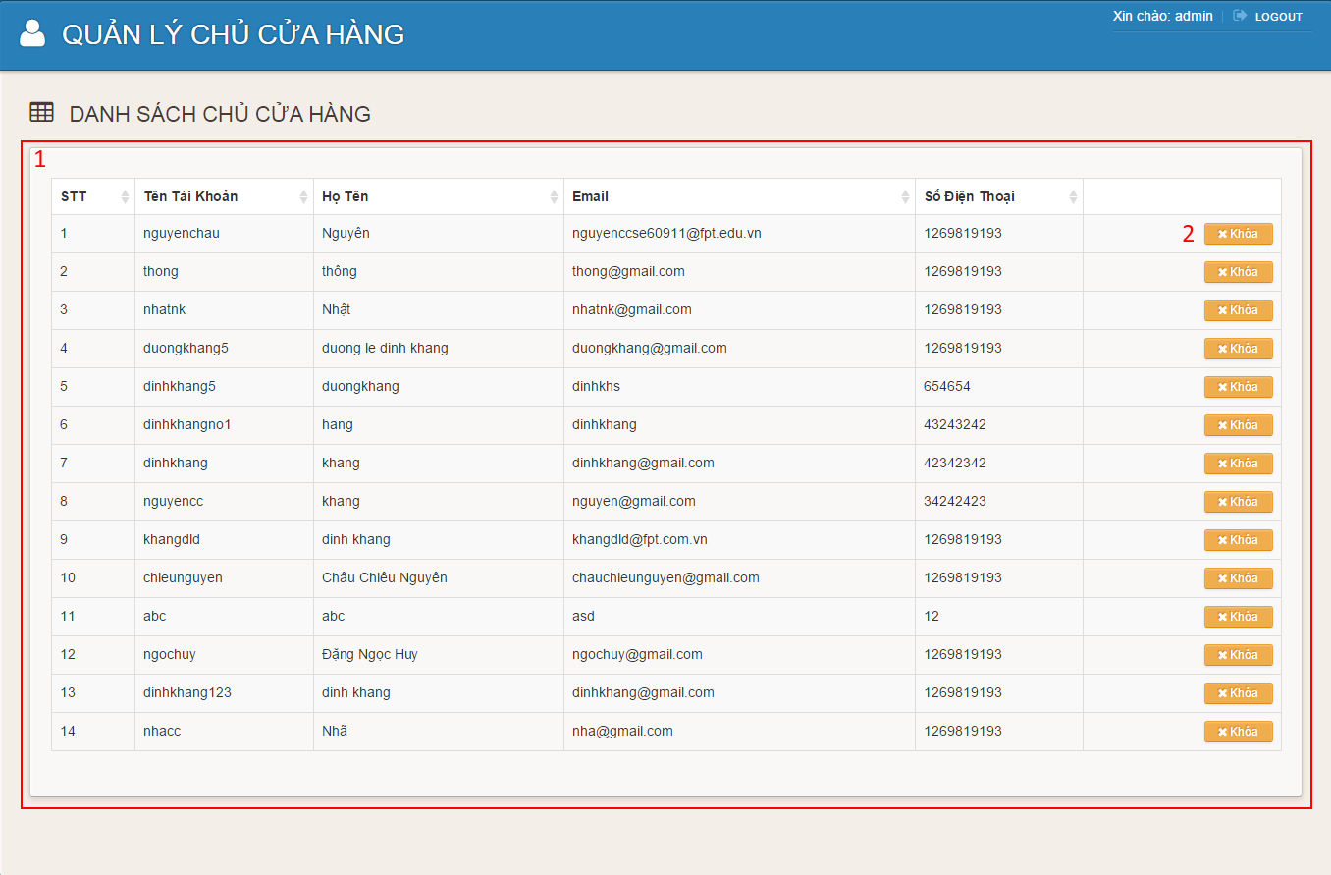**Figure 4: Admin Manage Storeowners**

**Fields**

|  |  |  |  |  |  |  |  |
| --- | --- | --- | --- | --- | --- | --- | --- |
| **No** | **Field Name** | **Description** | **Read only** | **Mandatory** | **Control Type** | **Data Type** | **Length** |
| 1 | Storeowner’s table | Table to show storeowners | Yes | No | Data Table | N/A | N/A |

**Buttons/Hyperlinks**

|  |  |  |  |  |
| --- | --- | --- | --- | --- |
| **No** | **Function** | **Description** | **Validation** | **Outcome** |
| 2 | Lock | Click to lock storeowner | N/A | Transfer to manage storeowners page |

### Storeowner Interface Design (Website)

#### Register

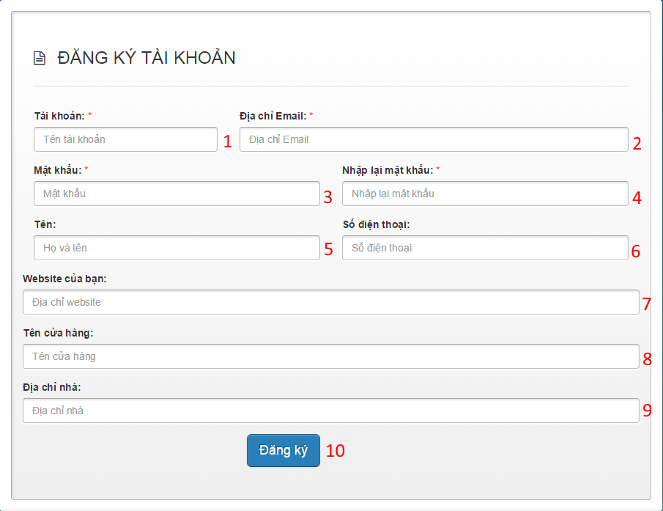**Figure 5: Register**

**Fields**

|  |  |  |  |  |  |  |  |
| --- | --- | --- | --- | --- | --- | --- | --- |
| **No** | **Field Name** | **Description** | **Read only** | **Mandatory** | **Control Type** | **Data Type** | **Length** |
| 1 | Username | Fill username | No | Yes | Textbox | String | N/A |
| 2 | Email | Fill email address | No | Yes | Textbox | String | N/A |
| 3 | Password | Fill password | No | Yes | Password | String | N/A |
| 4 | Confirm password | Fill confirm password | No | Yes | Password | String | N/A |
| 5 | Full name | Fill full name | No | No | Textbox | String | N/A |
| 6 | Phone number | Fill phone number | No | No | Textbox | String | N/A |
| 7 | Website | Fill website | No | No | Textbox | String | N/A |
| 8 | Store name | Fill store name | No | No | Textbox | String | N/A |
| 9 | Address | Fill address | No | No | Textbox | String | N/A |

**Buttons/Hyperlinks**

|  |  |  |  |  |
| --- | --- | --- | --- | --- |
| **No** | **Function** | **Description** | **Validation** | **Outcome** |
| 10 | Register | Click to register | N/A | Transfer to welcome page |

#### Storeowner Login

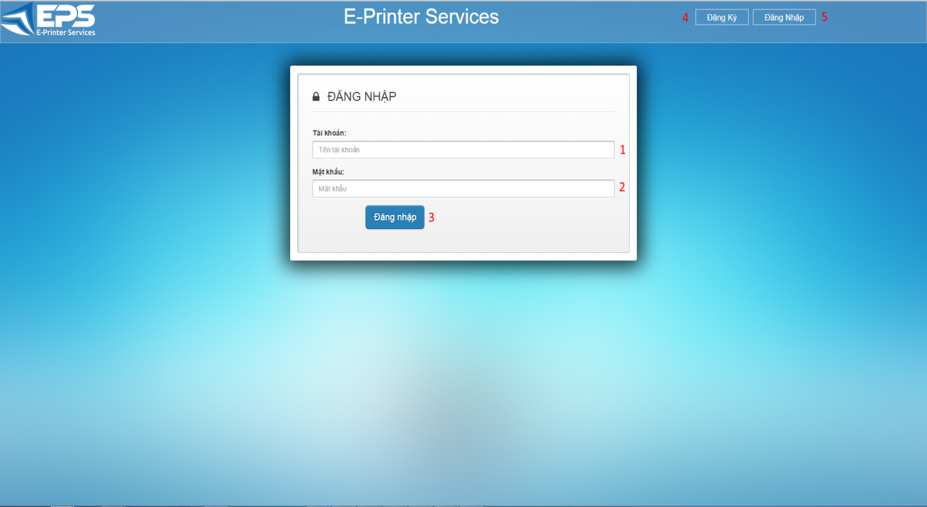

**Figure 6: Storeowner Login**

**Fields**

|  |  |  |  |  |  |  |  |
| --- | --- | --- | --- | --- | --- | --- | --- |
| **No** | **Field Name** | **Description** | **Read only** | **Mandatory** | **Control Type** | **Data Type** | **Length** |
| 1 | Username | Fill user name | No | Yes | Textbox | String | N/A |
| 2 | Password | Fill password | No | Yes | Password | String | N/A |

**Buttons/Hyperlinks**

|  |  |  |  |  |
| --- | --- | --- | --- | --- |
| **No** | **Function** | **Description** | **Validation** | **Outcome** |
| 3 | Sign in | Log-in into the system | N/A | Transfer to storeowner home page |
| 4 | Register | Click to go to register page | N/A | Transfer to register page |
| 5 | Sign in | Click to go to login page | N/A | Transfer to login page |

#### Storeowner Home Page

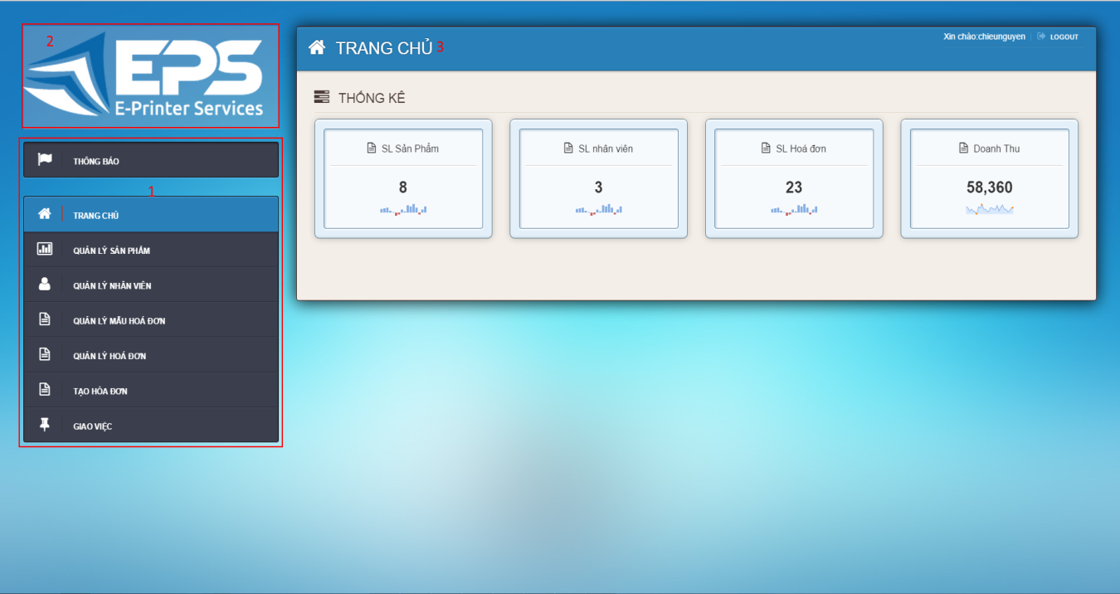

**Figure 7: Storeowner Home Page**

**Fields**

|  |  |  |  |  |  |  |  |
| --- | --- | --- | --- | --- | --- | --- | --- |
| **No** | **Field Name** | **Description** | **Read only** | **Mandatory** | **Control Type** | **Data Type** | **Length** |
| 1 | Menu | Navigation bar | No | No | Menu bar | N/A | N/A |
| 2 | Logo | Logo of the system | Yes | No | Image | Image | N/A |
| 3 | Title | Title of the page | Yes | Yes | Label | String | N/A |

#### Notification

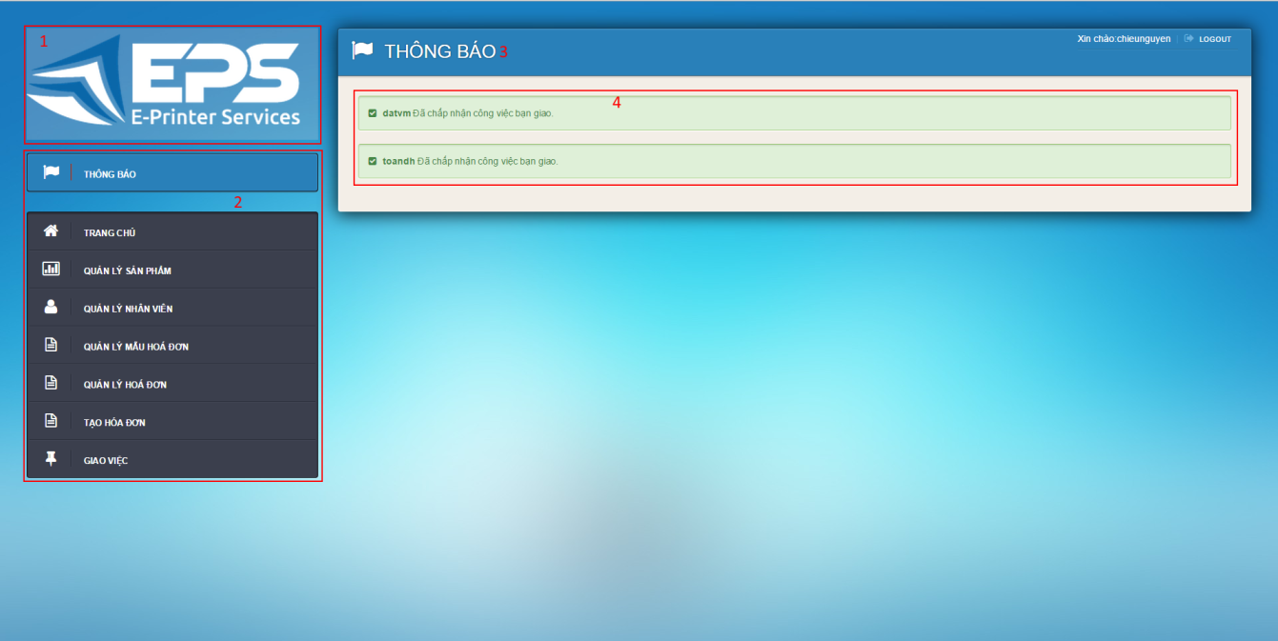

**Figure 8: Notification**

**Fields**

|  |  |  |  |  |  |  |  |
| --- | --- | --- | --- | --- | --- | --- | --- |
| **No** | **Field Name** | **Description** | **Read only** | **Mandatory** | **Control Type** | **Data Type** | **Length** |
| 1 | Menu | Navigation bar | No | No | Menu bar | N/A | N/A |
| 2 | Logo | Logo of the system | Yes | No | Image | Image | N/A |
| 3 | Title | Title of the page | Yes | Yes | Label | String | N/A |
| 4 | Notification | Notification from employee | Yes | Yes | Label | String | N/A |

#### Manage Item

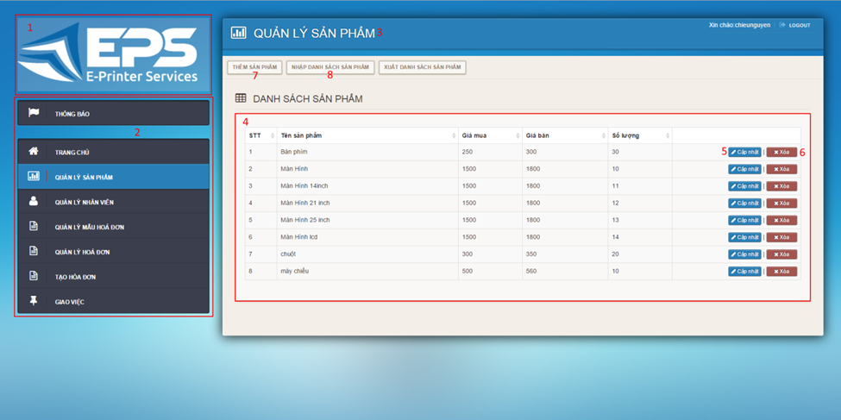

**Figure 9: Mange Items**

**Fields**

|  |  |  |  |  |  |  |  |
| --- | --- | --- | --- | --- | --- | --- | --- |
| **No** | **Field Name** | **Description** | **Read only** | **Mandatory** | **Control Type** | **Data Type** | **Length** |
| 1 | Logo | Logo of the system | Yes | No | Image | Image | N/A |
| 2 | Menu | Navigation bar | No | No | Menu bar | N/A | N/A |
| 3 | Title | Title of the page | Yes | Yes | Label | String | N/A |
| 4 | Item’s Table | Table to show items | Yes | Yes | Data Table | N/A | N/A |

**Buttons/Hyperlinks**

|  |  |  |  |  |
| --- | --- | --- | --- | --- |
| **No** | **Function** | **Description** | **Validation** | **Outcome** |
| 5 | Update | Click to go to update item page | N/A | Transfer to update item page |
| 6 | Delete | Delete an item | N/A | Transfer to manage item page |
| 7 | Add | Click to go to add item page | N/A | Transfer to add item page |
| 8 | Import Item | Click to go to import item page |  | Transfer to import item page |

#### Add Item

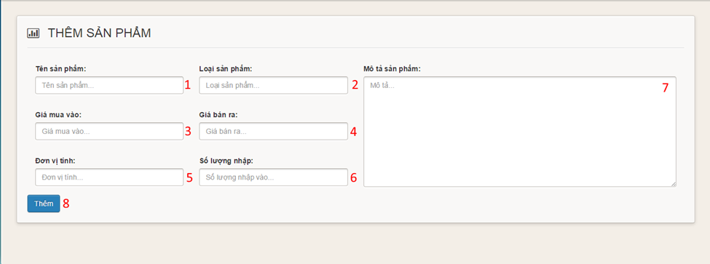

**Figure 10: Add Item**

**Fields**

|  |  |  |  |  |  |  |  |
| --- | --- | --- | --- | --- | --- | --- | --- |
| **No** | **Field Name** | **Description** | **Read only** | **Mandatory** | **Control Type** | **Data Type** | **Length** |
| 1 | Item name | Fill Item name | No | Yes | Textbox | String | N/A |
| 2 | Item type | Fill item type | No | Yes | Textbox | String | N/A |
| 3 | Supply price | Fill supply price | No | Yes | Textbox | String | N/A |
| 4 | Retail price | Fill retail price | No | Yes | Textbox | String | N/A |
| 5 | Item unit | Fill item unit | No | Yes | Textbox | String | N/A |
| 6 | Item quantity | Fill item quantity | No | Yes | Textbox | String | N/A |
| 7 | Description | Fill description | No | Yes | Text area | String | N/A |

**Buttons/Hyperlinks**

|  |  |  |  |  |
| --- | --- | --- | --- | --- |
| **No** | **Function** | **Description** | **Validation** | **Outcome** |
| 8 | Add | Click to add item | N/A | Transfer to manage item page |

#### Import Item

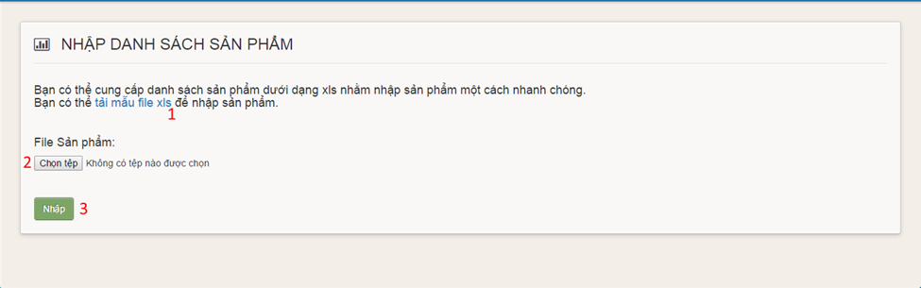

**Figure 11: Import Item**

**Buttons/Hyperlinks**

|  |  |  |  |  |
| --- | --- | --- | --- | --- |
| **No** | **Function** | **Description** | **Validation** | **Outcome** |
| 1 | Item template link | Click to download item template | N/A | Download item template |
| 2 | Choose file | Click to open choose file dialog | N/A | Display choose file dialog |
| 3 | Upload | Click to upload items | N/A | Transfer to manage items page |

#### Update Item

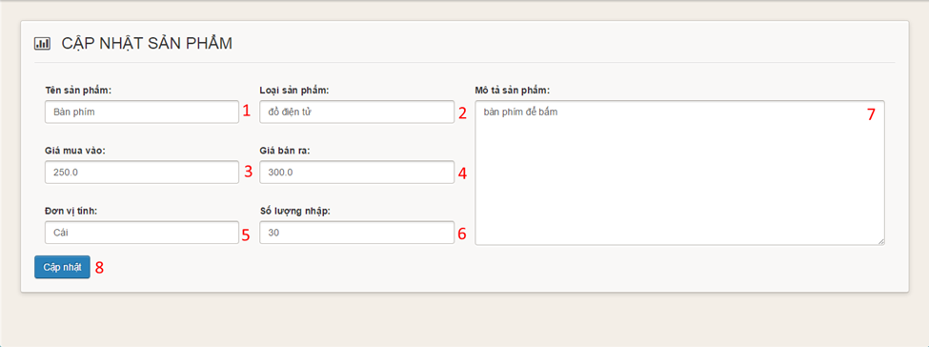

**Figure 12: Update Item**

**Fields**

|  |  |  |  |  |  |  |  |
| --- | --- | --- | --- | --- | --- | --- | --- |
| **No** | **Field Name** | **Description** | **Read only** | **Mandatory** | **Control Type** | **Data Type** | **Length** |
| 1 | Item name | Fill Item name | No | Yes | Textbox | String | N/A |
| 2 | Item type | Fill item type | No | Yes | Textbox | String | N/A |
| 3 | Supply price | Fill supply price | No | Yes | Textbox | String | N/A |
| 4 | Retail price | Fill retail price | No | Yes | Textbox | String | N/A |
| 5 | Item unit | Fill item unit | No | Yes | Textbox | String | N/A |
| 6 | Item quantity | Fill item quantity | No | Yes | Textbox | String | N/A |
| 7 | Description | Fill description | No | Yes | Text area | String | N/A |

**Buttons/Hyperlinks**

|  |  |  |  |  |
| --- | --- | --- | --- | --- |
| **No** | **Function** | **Description** | **Validation** | **Outcome** |
| 8 | Add | Click to update item | N/A | Transfer to manage item page |

#### Manage Employee

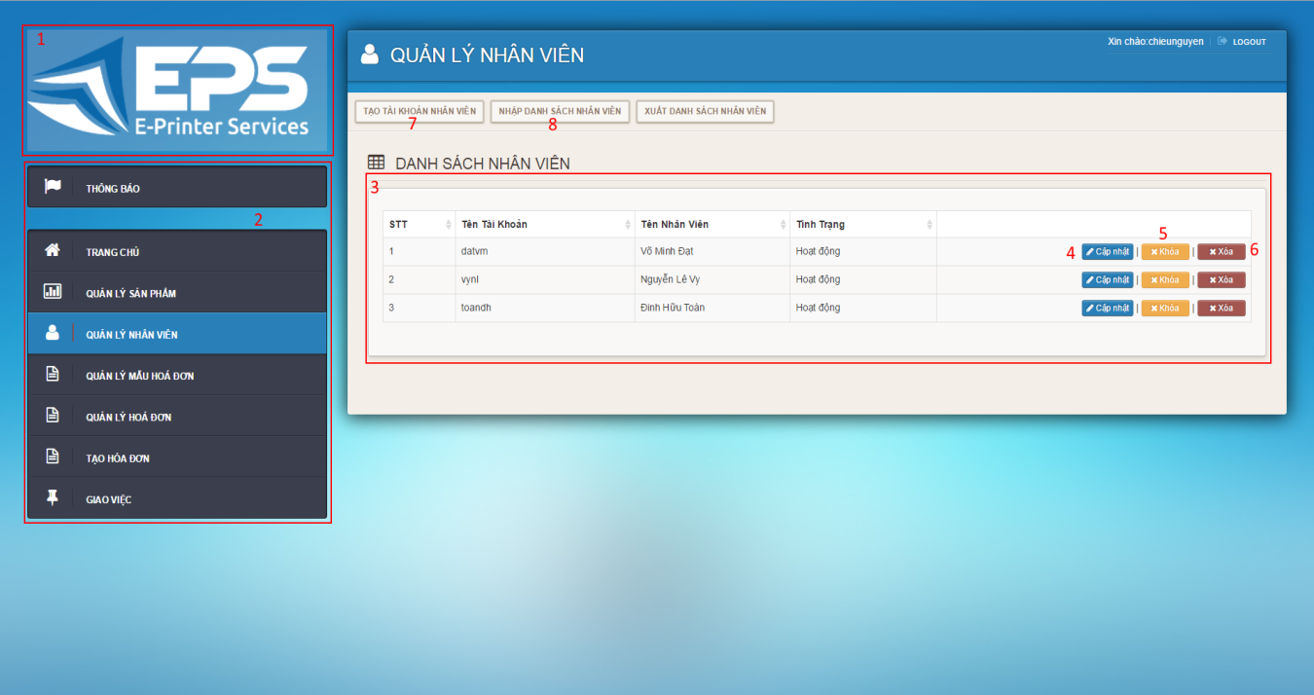**Figure 13: Manage Employees**

**Fields**

|  |  |  |  |  |  |  |  |
| --- | --- | --- | --- | --- | --- | --- | --- |
| **No** | **Field Name** | **Description** | **Read only** | **Mandatory** | **Control Type** | **Data Type** | **Length** |
| 1 | Logo | Logo of the system | Yes | No | Image | Image | N/A |
| 2 | Menu | Navigation bar | No | No | Menu bar | N/A | N/A |
| 3 | Employee’s Table | Table to show employees | Yes | Yes | Data Table | N/A | N/A |

**Buttons/Hyperlinks**

|  |  |  |  |  |
| --- | --- | --- | --- | --- |
| **No** | **Function** | **Description** | **Validation** | **Outcome** |
| 4 | Update | Click to go to update employee page | N/A | Transfer to update employees page |
| 5 | Lock | Click to lock employee | N/A | Transfer to manage employees page |
| 6 | Delete | Delete an employee | N/A | Transfer to manage employees page |
| 7 | Add | Click to go to add employee page | N/A | Transfer to add employees page |
| 8 | Import Employees | Click to go to import employee page | N/A | Transfer to import employees page |

#### Add Employee

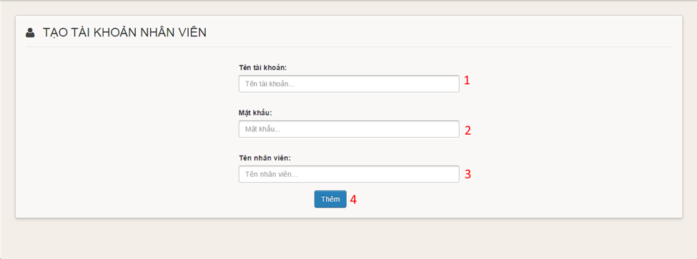

**Figure 14: Add Employee**

**Fields**

|  |  |  |  |  |  |  |  |
| --- | --- | --- | --- | --- | --- | --- | --- |
| **No** | **Field Name** | **Description** | **Read only** | **Mandatory** | **Control Type** | **Data Type** | **Length** |
| 1 | Username | Fill employee username | No | Yes | Textbox | String | N/A |
| 2 | Password | Fill employee password | No | Yes | Password | String | N/A |
| 3 | Full name | Fill employee full name | No | No | Textbox | String | N/A |

**Buttons/Hyperlinks**

|  |  |  |  |  |
| --- | --- | --- | --- | --- |
| **No** | **Function** | **Description** | **Validation** | **Outcome** |
| 4 | Add | Click to add employee | N/A | Transfer to manage employee page |

#### Import Employee

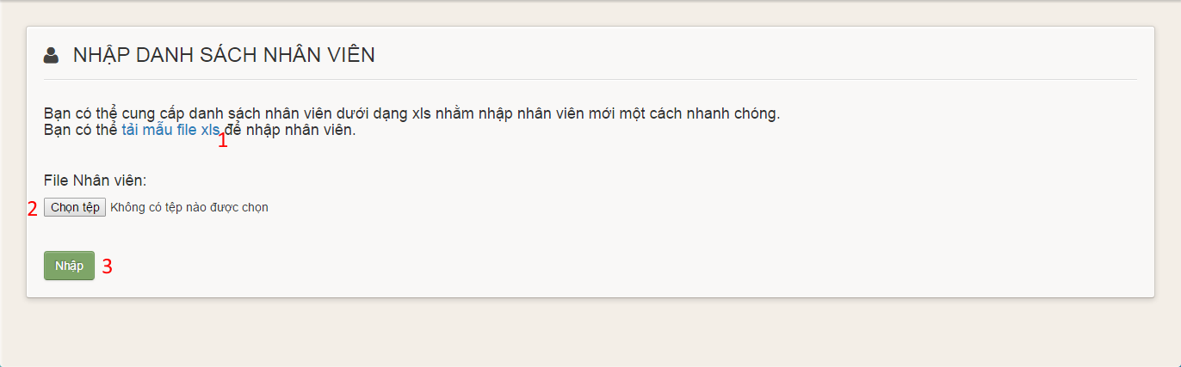**Figure 15: Import Employee**

**Buttons/Hyperlinks**

|  |  |  |  |  |
| --- | --- | --- | --- | --- |
| **No** | **Function** | **Description** | **Validation** | **Outcome** |
| 1 | Employee template link | Click to download employee template | N/A | Download employee template |
| 2 | Choose file | Click to open choose file dialog | N/A | Display choose file dialog |
| 3 | Upload | Click to upload employees | N/A | Transfer to manage employees page |

#### Update Employee

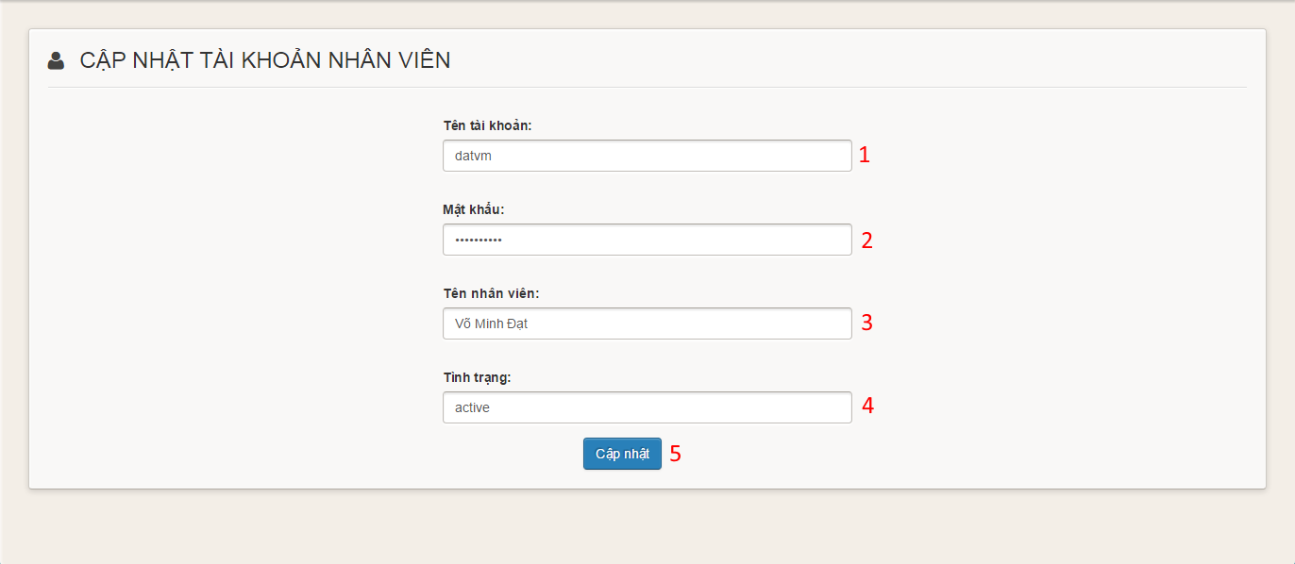

**Figure 16: Update Employee**

**Fields**

|  |  |  |  |  |  |  |  |
| --- | --- | --- | --- | --- | --- | --- | --- |
| **No** | **Field Name** | **Description** | **Read only** | **Mandatory** | **Control Type** | **Data Type** | **Length** |
| 1 | Username | Fill employee username | No | Yes | Textbox | String | N/A |
| 2 | Password | Fill employee password | No | Yes | Password | String | N/A |
| 3 | Full name | Fill employee full name | No | No | Textbox | String | N/A |
| 4 | Status | Fill employee status | No | Yes | Combobox | String | N/A |

**Buttons/Hyperlinks**

|  |  |  |  |  |
| --- | --- | --- | --- | --- |
| **No** | **Function** | **Description** | **Validation** | **Outcome** |
| 5 | Add | Click to update employee | N/A | Transfer to manage employee page |

#### Storeowner Manage Templates

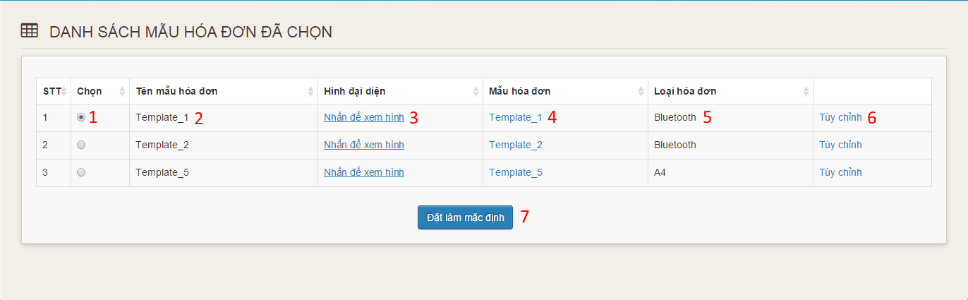

**Figure 17: Storeowner Manage Templates**

**Fields**

|  |  |  |  |  |  |  |  |
| --- | --- | --- | --- | --- | --- | --- | --- |
| **No** | **Field Name** | **Description** | **Read only** | **Mandatory** | **Control Type** | **Data Type** | **Length** |
| 1 | Choose | Choose default template | No | Yes | Radiobutton | N/A | N/A |
| 2 | Template Name | Display name of template | Yes | Yes | Label | String | N/A |
| 3 | Image link | Click to view image | No | Yes | Link | String | N/A |
| 4 | Template link | Click to download template | No | Yes | Link | String | N/A |
| 5 | Type | Display type of template | Yes | Yes | Label | String | N/A |
| 6 | Customize | Click to go to customize page | No | Yes | Link | String | N/A |

**Buttons/Hyperlinks**

|  |  |  |  |  |
| --- | --- | --- | --- | --- |
| **No** | **Function** | **Description** | **Validation** | **Outcome** |
| 7 | Set Default | Click to set default template | N/A | Transfer to manage template page |

#### Customize Bluetooth Template

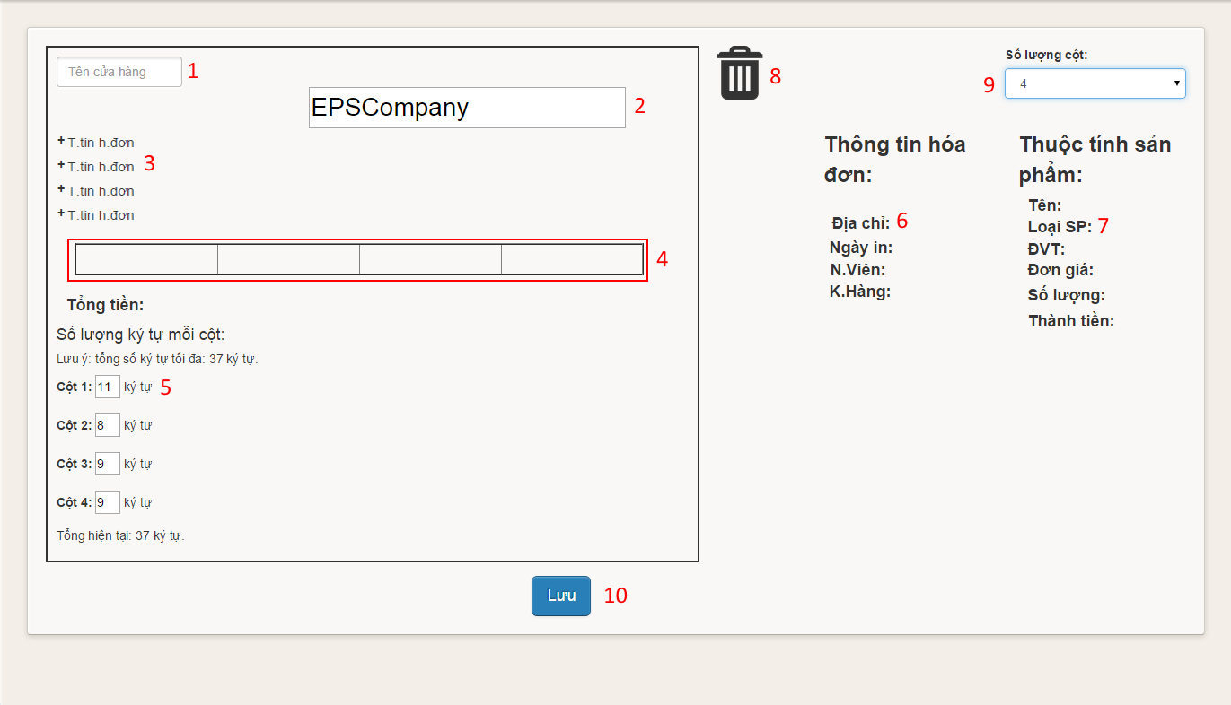

**Figure 18: Customize Bluetooth Template**

**Fields**

|  |  |  |  |  |  |  |  |
| --- | --- | --- | --- | --- | --- | --- | --- |
| **No** | **Field Name** | **Description** | **Read only** | **Mandatory** | **Control Type** | **Data Type** | **Length** |
| 1 | Store Name | Fill store name | No | Yes | Textbox | String | N/A |
| 2 | Template Title | Fill template title | No | Yes | Textbox | String | N/A |
| 3 | Order Information Position | Fill order information | Yes | Yes | Label | String | N/A |
| 4 | Item Information Position | Fill item information | Yes | Yes | Table | N/A | N/A |
| 5 | Columns limit characters | Fill limit characters | No | Yes | Textbox | String | 2 |
| 6 | Order Information | Order Information | Yes | Yes | Image | Image | N/A |
| 7 | Item Information | Item Information | Yes | Yes | Image | Image | N/A |
| 8 | Trash | To remove information | Yes | Yes | Image | Image | N/A |
| 9 | Number Of Columns | Fill number of columns | No | Yes | Combobox | String | N/A |

**Buttons/Hyperlinks**

|  |  |  |  |  |
| --- | --- | --- | --- | --- |
| **No** | **Function** | **Description** | **Validation** | **Outcome** |
| 10 | Save | Click to customize template | N/A | Transfer to manage template page |

#### Customize A4 Template

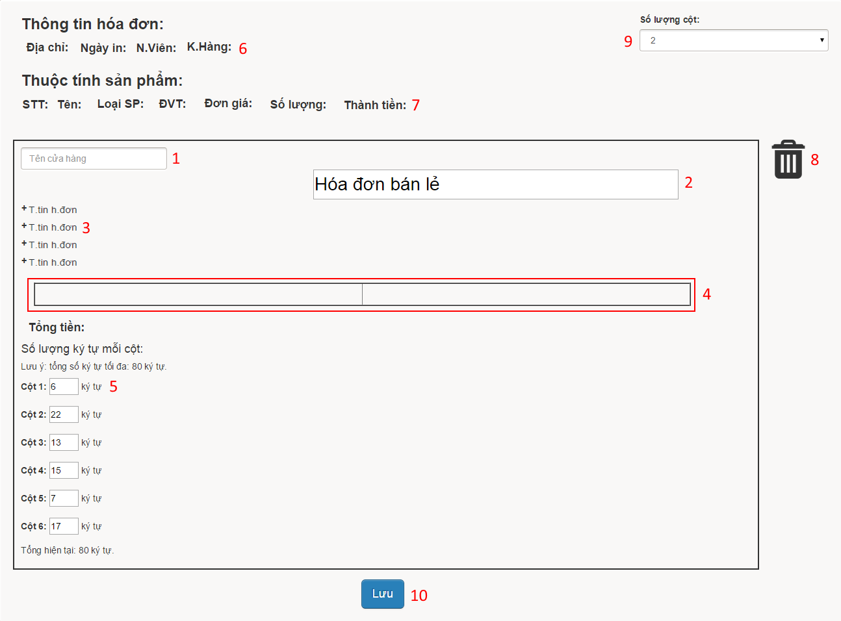

**Figure 19: Customize A4 Template**

**Fields**

|  |  |  |  |  |  |  |  |
| --- | --- | --- | --- | --- | --- | --- | --- |
| **No** | **Field Name** | **Description** | **Read only** | **Mandatory** | **Control Type** | **Data Type** | **Length** |
| 1 | Store Name | Fill store name | No | Yes | Textbox | String | N/A |
| 2 | Template Title | Fill template title | No | Yes | Textbox | String | N/A |
| 3 | Order Information Position | Fill order information | Yes | Yes | Label | String | N/A |
| 4 | Item Information Position | Fill item information | Yes | Yes | Table | N/A | N/A |
| 5 | Columns limit characters | Fill limit characters | No | Yes | Textbox | String | 2 |
| 6 | Order Information | Order Information | Yes | Yes | Image | Image | N/A |
| 7 | Item Information | Item Information | Yes | Yes | Image | Image | N/A |
| 8 | Trash | To remove information | Yes | Yes | Image | Image | N/A |
| 9 | Number Of Columns | Fill number of columns | No | Yes | Combobox | String | N/A |

**Buttons/Hyperlinks**

|  |  |  |  |  |
| --- | --- | --- | --- | --- |
| **No** | **Function** | **Description** | **Validation** | **Outcome** |
| 10 | Save | Click to customize template | N/A | Transfer to manage template page |

#### Manage Order

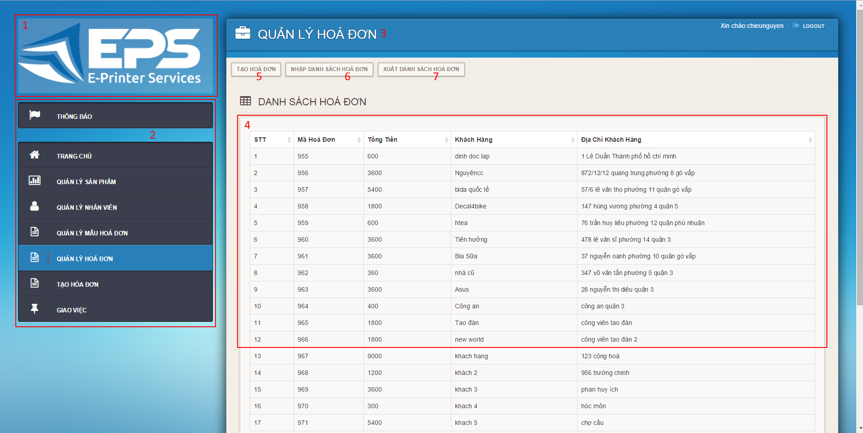

**Figure 20: Manage Orders**

**Fields**

|  |  |  |  |  |  |  |  |
| --- | --- | --- | --- | --- | --- | --- | --- |
| **No** | **Field Name** | **Description** | **Read only** | **Mandatory** | **Control Type** | **Data Type** | **Length** |
| 1 | Logo | Logo of the system | Yes | No | Image | Image | N/A |
| 2 | Menu | Navigation bar | No | No | Menu bar | N/A | N/A |
| 3 | Title | Title of the page | Yes | Yes | Label | N/A | N/A |
| 4 | Order’s Table | Table to show orders | Yes | Yes | Data Table | N/A | N/A |

**Buttons/Hyperlinks**

|  |  |  |  |  |
| --- | --- | --- | --- | --- |
| **No** | **Function** | **Description** | **Validation** | **Outcome** |
| 5 | Create | Click to go to create order page | N/A | Transfer to create order page |
| 6 | Import | Click to go to import order page | N/A | Transfer to import order page |
| 7 | Export | Click to go to export order page | N/A | Transfer to export order page |

#### Create Order

##### CreateOrder1Create Order step 1

**Figure 21: Create Order step 1**

**Fields**

|  |  |  |  |  |  |  |  |
| --- | --- | --- | --- | --- | --- | --- | --- |
| **No** | **Field Name** | **Description** | **Read only** | **Mandatory** | **Control Type** | **Data Type** | **Length** |
| 1 | Choose Template | Click to choose template | No | Yes | Combobox | String | N/A |

**Buttons/Hyperlinks**

|  |  |  |  |  |
| --- | --- | --- | --- | --- |
| **No** | **Function** | **Description** | **Validation** | **Outcome** |
| 2 | Continue | Click to go to create order step 2 | N/A | Display create order step 2 |

##### Create Order step 2

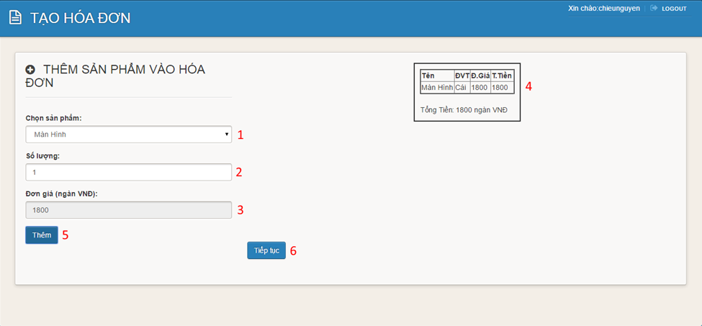

**Figure 22: Create Order step 2**

**Fields**

|  |  |  |  |  |  |  |  |
| --- | --- | --- | --- | --- | --- | --- | --- |
| **No** | **Field Name** | **Description** | **Read only** | **Mandatory** | **Control Type** | **Data Type** | **Length** |
| 1 | Choose Item | Click to item template | No | Yes | Combobox | String | N/A |
| 2 | Quantity | Fill quantity of item | No | Yes | Textbox | String | N/A |
| 3 | Price | Display price of item | Yes | Yes | Textbox | String | N/A |
| 4 | Order | Display order | Yes | Yes | Image | Image | N/A |

**Buttons/Hyperlinks**

|  |  |  |  |  |
| --- | --- | --- | --- | --- |
| **No** | **Function** | **Description** | **Validation** | **Outcome** |
| 5 | Add | Click to add item to order | N/A | Add item to order |
| 6 | Continue | Click to go to create order step 3 | N/A | Display create order step 3 |

##### Create Order step 3

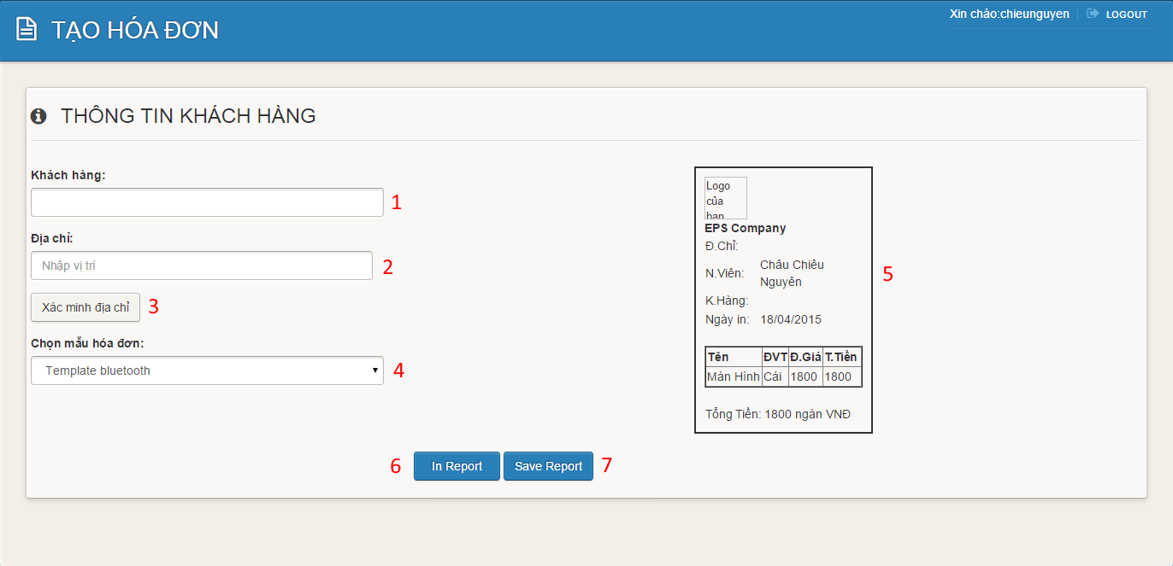**Figure 23: Create Order step 3**

**Fields**

|  |  |  |  |  |  |  |  |
| --- | --- | --- | --- | --- | --- | --- | --- |
| **No** | **Field Name** | **Description** | **Read only** | **Mandatory** | **Control Type** | **Data Type** | **Length** |
| 1 | Customer Name | Fill customer name | No | Yes | Textbox | String | N/A |
| 2 | Address | Fill address of customer | No | Yes | Textbox | String | N/A |
| 4 | Choose Template | Click to choose template | No | Yes | Combobox | String | N/A |
| 5 | Order | Display order | Yes | Yes | Image | Image | N/A |

**Buttons/Hyperlinks**

|  |  |  |  |  |
| --- | --- | --- | --- | --- |
| **No** | **Function** | **Description** | **Validation** | **Outcome** |
| 3 | Confirm Address | Click to go to confirm address page | N/A | Transfer to confirm address page |
| 6 | Print | Click to go to print order page | N/A | Display print order page |
| 7 | Save | Click to save order | N/A | Transfer to manage order page |

#### Import Orders

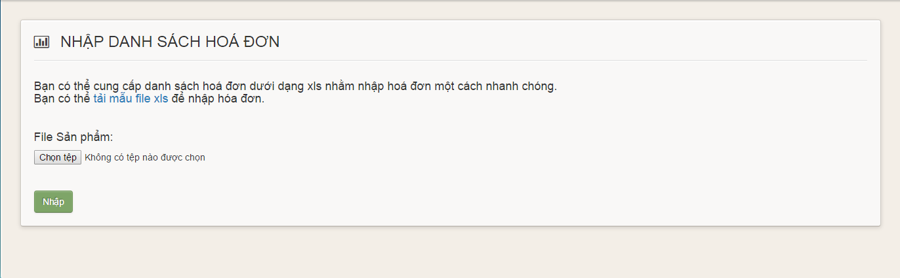**Figure 24: Import Orders**

**Buttons/Hyperlinks**

|  |  |  |  |  |
| --- | --- | --- | --- | --- |
| **No** | **Function** | **Description** | **Validation** | **Outcome** |
| 1 | Order template link | Click to download order template | N/A | Download order template |
| 2 | Choose file | Click to open choose file dialog | N/A | Display choose file dialog |
| 3 | Upload | Click to upload orders | N/A | Transfer to manage orders page |

#### Assign Order

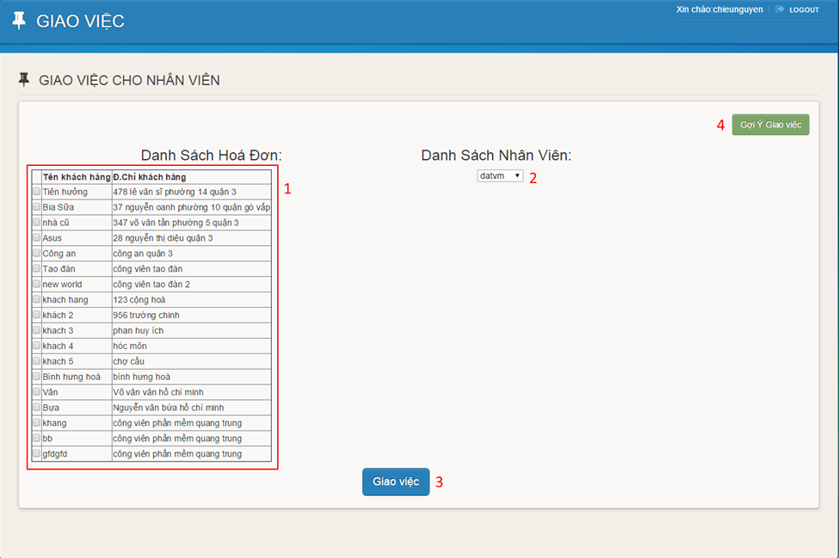

**Figure 25: Assign Order**

**Fields**

|  |  |  |  |  |  |  |  |
| --- | --- | --- | --- | --- | --- | --- | --- |
| **No** | **Field Name** | **Description** | **Read only** | **Mandatory** | **Control Type** | **Data Type** | **Length** |
| 1 | Order Table | Display orders | Yes | Yes | Data Table | N/A | N/A |
| 2 | Choose Employee | Click to choose employee | Yes | Yes | Combobox | String | N/A |

**Buttons/Hyperlinks**

|  |  |  |  |  |
| --- | --- | --- | --- | --- |
| **No** | **Function** | **Description** | **Validation** | **Outcome** |
| 3 | Assign Order | Click to assign order to employee | N/A | Transfer to storeowner home page |
| 4 | Suggest | Click to suggest assigning order | N/A | Transfer to suggesting page. |

#### Choose Template

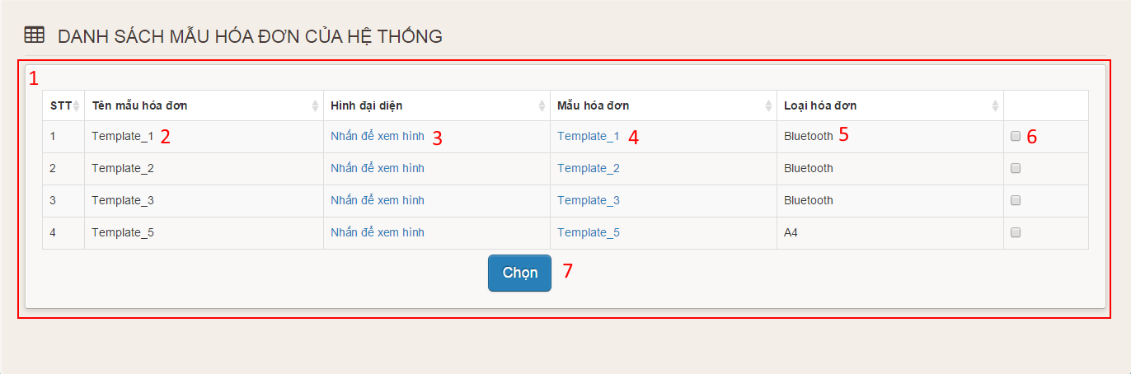

**Figure 26: Choose Template**

**Fields**

|  |  |  |  |  |  |  |  |
| --- | --- | --- | --- | --- | --- | --- | --- |
| **No** | **Field Name** | **Description** | **Read only** | **Mandatory** | **Control Type** | **Data Type** | **Length** |
| 1 | Template Table | Display templates of the system | Yes | Yes | Data Table | N/A | N/A |
| 2 | Template Name | Display name of template | Yes | Yes | Label | String | N/A |
| 3 | Image link | Click to view image | No | Yes | Link | String | N/A |
| 4 | Template link | Click to download template | No | Yes | Link | String | N/A |
| 5 | Type | Display type of template | Yes | Yes | Label | String | N/A |
| 6 | Choose | Click choose template | No | Yes | Checkbox | N/A | N/A |

**Buttons/Hyperlinks**

|  |  |  |  |  |
| --- | --- | --- | --- | --- |
| **No** | **Function** | **Description** | **Validation** | **Outcome** |
| 7 | Choose | Click to choose template | N/A | Transfer to manage template page |

### Employee Interface Design

#### Login screen

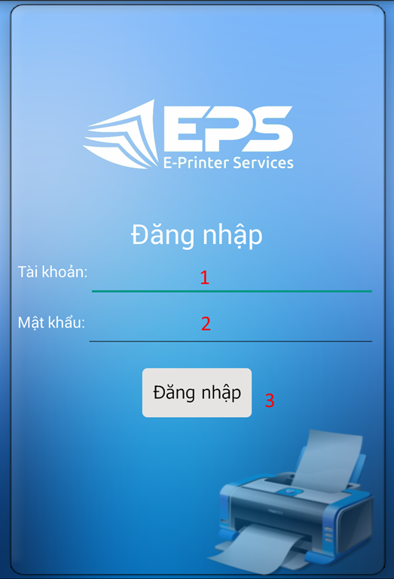

**Figure 27: Mobile Login**

**Fields**

|  |  |  |  |  |  |  |  |
| --- | --- | --- | --- | --- | --- | --- | --- |
| **No** | **Field Name** | **Description** | **Read only** | **Mandatory** | **Control Type** | **Data Type** | **Length** |
| 1 | Username | Fill username | No | Yes | Textbox | String | N/A |
| 2 | Password | Fill password | No | Yes | Password | String | N/A |

**Buttons/Hyperlinks**

|  |  |  |  |  |
| --- | --- | --- | --- | --- |
| **No** | **Function** | **Description** | **Validation** | **Outcome** |
| 3 | Sign in | Log-in into the Android application | N/A | Transfer to menu screen |

#### Menu screen

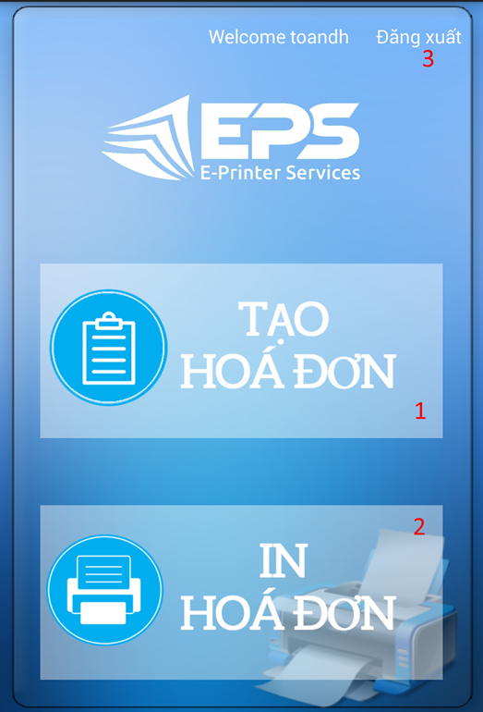

**Figure 28: Mobile Menu**

**Buttons/Hyperlinks**

|  |  |  |  |  |
| --- | --- | --- | --- | --- |
| **No** | **Function** | **Description** | **Validation** | **Outcome** |
| 1 | Create order | Touch to go to create order screen | N/A | Transfer to create order screen |
| 2 | Print order | Touch to go to view order screen | N/A | Transfer to view order screen |
| 3 | Logout link | Touch to logout | N/A | Transfer to login screen |

#### Create Order

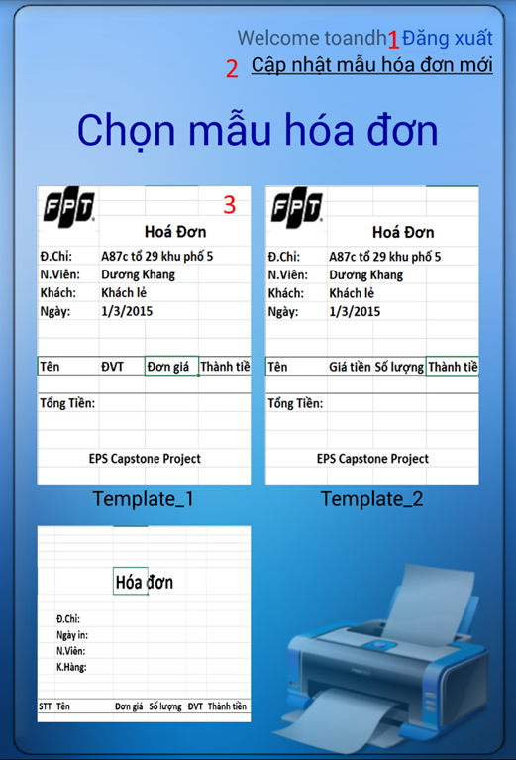

**Figure 29: Create Order**

**Buttons/Hyperlinks**

|  |  |  |  |  |
| --- | --- | --- | --- | --- |
| **No** | **Function** | **Description** | **Validation** | **Outcome** |
| 1 | Logout link | Touch to logout | N/A | Transfer to login screen |
| 2 | Update templates link | Touch to update templates | N/A | Display new templates |
| 3 | Image of template | Touch to choose template | N/A | Transfer to input item screen |

#### Input Item Screen

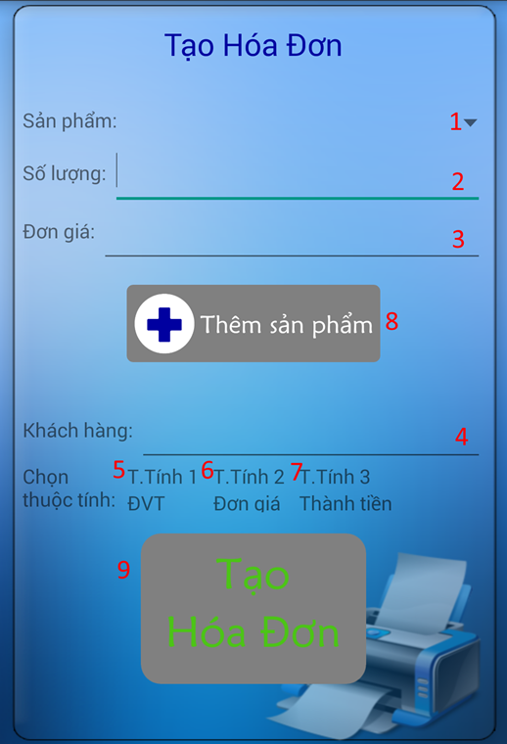

**Figure 30: Input Item**

**Fields**

|  |  |  |  |  |  |  |  |
| --- | --- | --- | --- | --- | --- | --- | --- |
| **No** | **Field Name** | **Description** | **Read only** | **Mandatory** | **Control Type** | **Data Type** | **Length** |
| 1 | Item | Choose item | No | Yes | Combo box | String | N/A |
| 2 | Quantity | Fill quantity | No | Yes | Textbox | String | N/A |
| 3 | Price | Display price | Yes | Yes | Textbox | String | N/A |
| 4 | Customer name | Fill customer name | No | No | Textbox | String | N/A |

**Buttons/Hyperlinks**

|  |  |  |  |  |
| --- | --- | --- | --- | --- |
| **No** | **Function** | **Description** | **Validation** | **Outcome** |
| 5 | Attribute 1 | Touch to choose attribute 1 | N/A | Display attribute 1 |
| 6 | Attribute 2 | Touch to choose attribute 2 | N/A | Display attribute 2 |
| 7 | Attribute 3 | Touch to choose attribute 3 | N/A | Display attribute 3 |
| 8 | Add item | Touch to add item to order | N/A | Display message “Đã thêm”. |
| 9 | Create order | Touch to create order | N/A | Transfer to view order screen |

#### View Order screen

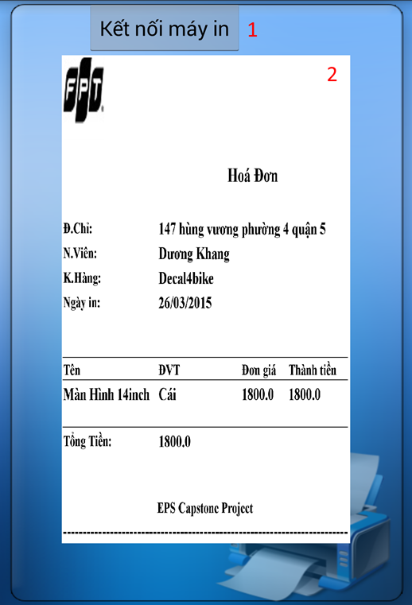

**Figure 31: View Order**

**Fields**

|  |  |  |  |  |  |  |  |
| --- | --- | --- | --- | --- | --- | --- | --- |
| **No** | **Field Name** | **Description** | **Read only** | **Mandatory** | **Control Type** | **Data Type** | **Length** |
| 2 | Order Image | Display order image | Yes | Yes | Image | Image | N/A |

**Buttons/Hyperlinks**

|  |  |  |  |  |
| --- | --- | --- | --- | --- |
| **No** | **Function** | **Description** | **Validation** | **Outcome** |
| 1 | Connect Printer | Touch to connect to printer | N/A | Transfer to search printer screen. |

#### Search Printer

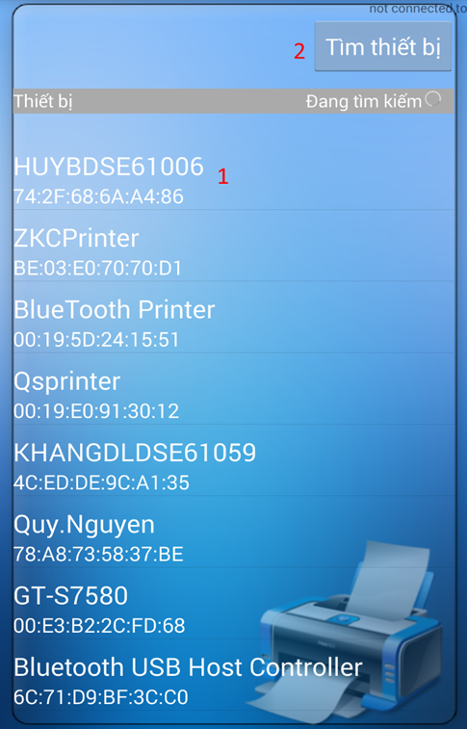

**Figure 32: Search Printer**

**Buttons/Hyperlinks**

|  |  |  |  |  |
| --- | --- | --- | --- | --- |
| **No** | **Function** | **Description** | **Validation** | **Outcome** |
| 1 | Printer | Touch to connect to printer | N/A | Transfer to print screen. |
| 2 | Search | Touch to search printer | N/A | Display list of printer |

#### Print Order

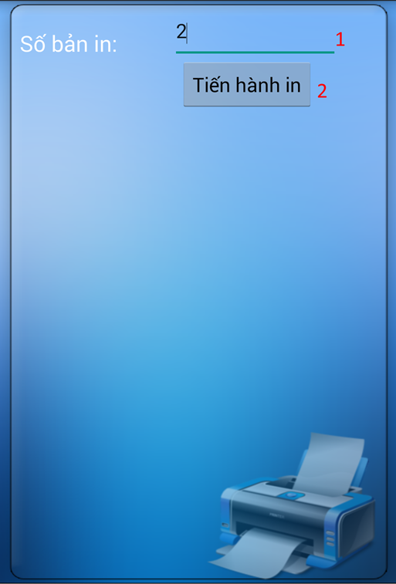

**Figure 33: Print Order**

**Fields**

|  |  |  |  |  |  |  |  |
| --- | --- | --- | --- | --- | --- | --- | --- |
| **No** | **Field Name** | **Description** | **Read only** | **Mandatory** | **Control Type** | **Data Type** | **Length** |
| 1 | Number of copies | Fill number of copies | No | Yes | Textbox | Number | N/A |

**Buttons/Hyperlinks**

|  |  |  |  |  |
| --- | --- | --- | --- | --- |
| **No** | **Function** | **Description** | **Validation** | **Outcome** |
| 2 | Print | Touch to print order | N/A | N/A |

#### View Order Information

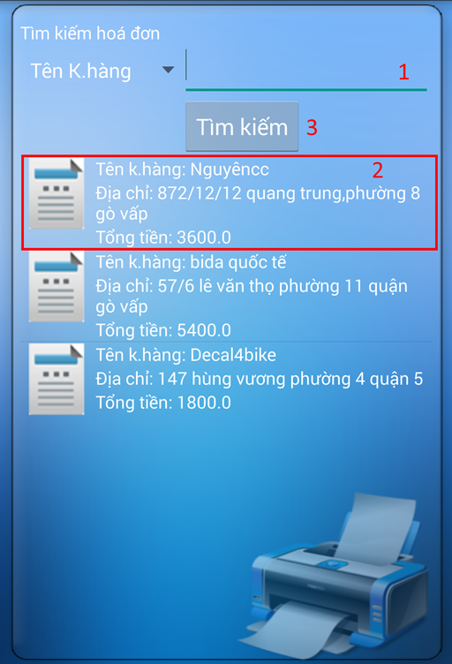

**Figure 34: View Order Information**

**Fields**

|  |  |  |  |  |  |  |  |
| --- | --- | --- | --- | --- | --- | --- | --- |
| **No** | **Field Name** | **Description** | **Read only** | **Mandatory** | **Control Type** | **Data Type** | **Length** |
| 1 | Customer name | Fill keywords to search | No | Yes | Textbox | String | N/A |

**Buttons/Hyperlinks**

|  |  |  |  |  |
| --- | --- | --- | --- | --- |
| **No** | **Function** | **Description** | **Validation** | **Outcome** |
| 2 | Order link | Touch to choose order | N/A | Transfer to choose template screen |
| 3 | Search | Touch to search order based on customer name | N/A | Display order |

#### Choose Template

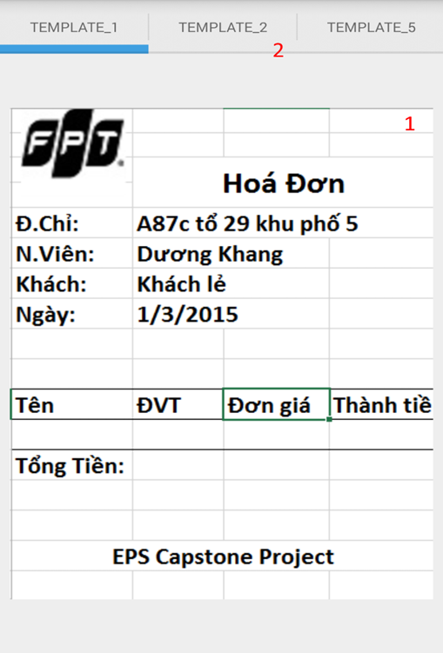

**Figure 35: Choose Template**

**Fields**

|  |  |  |  |  |  |  |  |
| --- | --- | --- | --- | --- | --- | --- | --- |
| **No** | **Field Name** | **Description** | **Read only** | **Mandatory** | **Control Type** | **Data Type** | **Length** |
| 1 | Menu | Display name of template | Yes | Yes | Menu | N/A | N/A |

**Buttons/Hyperlinks**

|  |  |  |  |  |
| --- | --- | --- | --- | --- |
| **No** | **Function** | **Description** | **Validation** | **Outcome** |
| 2 | Template Image | Touch to choose template | N/A | Transfer to view order screen |

## Database Design

### Logical Diagram

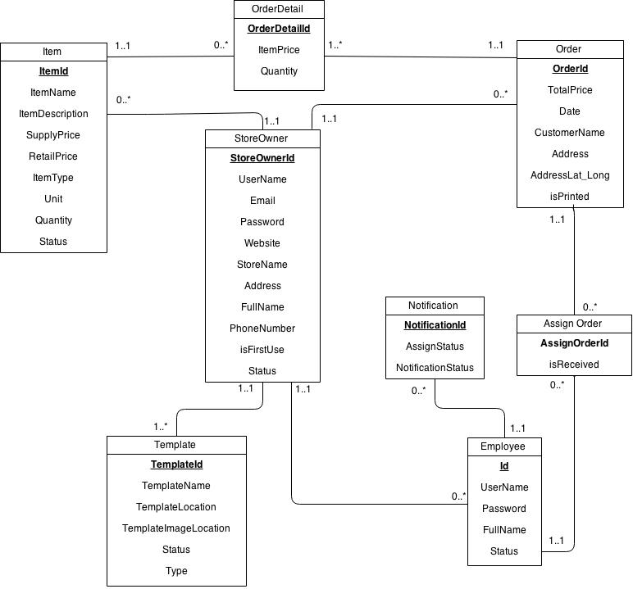

Figure 51: Logical Diagram

### Data Dictionary

|  |  |
| --- | --- |
| **Entity Data dictionary: describe content of all entities** | |
| Entity Name | Description |
| Items | Describe all Items in the system. |
| Store Owner | Describe all StoreOwners in the system. |
| Template | Describe all Templates available in the system. |
| Employee | Describe all Employees in the system. |
| Order | Describe all Order in the system. |
| Order Detail | Describe all Order Details in the system. |
| Notification | Describe all Notifications in the system. |
| Assign Order | Describe all templates available in the system. |

Table 7: Entity Data Dictionary

|  |  |  |  |  |
| --- | --- | --- | --- | --- |
| **Entity name** | **Attributes** | **Description** | **Domain** | **Null** |
| Store Owner | StoreOwnerId | Unique identifier of StoreOwner, auto increment. | int | No |
| UserName | StoreOwner’s username. | nvarchar(50) | No |
| Email | StoreOwner’s email address. | nvarchar(50) | No |
| Password | StoreOwner’s password. | nvarchar(50) | No |
| Website | StoreOwner’s website address. | nvarchar(50) | Yes |
| StoreName | Name of the store. | nvarchar(50) | No |
| Address | The address of StoreOwner. | nvarchar(100) | No |
| FullName | Full name of StoreOwner. | nvarchar(100) | No |
| PhoneNumber | Phone number of StoreOwner. | int | No |
| isFirstUse | Value to check whether StoreOwner log in for the first time or not. | bit | No |
| Status | Status of StoreOwner. | nchar(10) | No |
| Employee | Id | Unique identifier of employee, auto increment. | int | No |
| UserName | Employee’s username. | nchar(20) | No |
| Password | Employee’s password. | nchar(10) | No |
| FullName | Employee’s full name. | nvarchar(50) | Yes |
| Status | Status of employee. | nchar(20) | No |
| Item | ItemId | Unique identifier of item, auto increment. | int | No |
| ItemName | Name of an item. | nvarchar(100) | No |
| ItemDescription | Description about an item. | nvarchar(500) | Yes |
| SupplyPrice | Supply price of item. | float | No |
| RetailPrice | Retail price of item. | float | No |
| ItemType | Type of item. | nvarchar(50) | No |
| Unit | Unit of an item. | nvarchar(50) | No |
| Quantity | Quantity of item in store. | int | No |
| Status | Status of an item. | nchar(10) | No |
| Template | TemplateId | Unique identifier of template, auto increment. | int | No |
| TemplateName | Name of template. | nvarchar(50) | No |
| TemplateLocation | Location of template on server. | nvarchar(260) | No |
| TemplateImageLocation | Location of image template on server. | nvarchar(260) | No |
| Status | Status of template. | nvarchar(20) | No |
| Type | Type of template. | nchar(10) | No |
| Order | OrderId | Unique identifier of order, auto increment. | int | No |
| TotalPrice | Total price of order. | float | No |
| Date | Date order made. | datetime | No |
| CustomerName | Name of the customer. | nvarchar(30) | No |
| Address | Address of customer. | nvarchar(100) | No |
| AddressLat_Long | Latitude and longitude of address. | varchar(100) | No |
| isPrinted | Value to check whether the order is printed or not. | bit | No |
| OrderDetail | OrderDetailId | Unique identifier of orderdetail, auto increment. | int | No |
| ItemPrice | Price of an item in orderdetail. | float | No |
| Quantity | Quantity of items in order. | int | No |
| Notification | NotificationId | Unique identifier of notification, auto increment. | int | No |
| AssignStatus | Status of job assigned to employee | bit | No |
| NotificationStatus | Status of notification | bit | No |
| AssignOrder | AssignOrderId | Unique identifier of AssignOrder,auto increment | bit | No |
| isReceived | Status of each assign order | bit | No |

Table 8: Detail Data Dictionary

* Business integrity constraint:

- StoreOwner only can access to their items, employees and orders.

## Algorithms

### K-Medoids Algorithm

#### Definition

K-Medoids algorithm is clustering algorithm, which attempt to partition and minimize the distance between point labeled to be in a cluster and a point designated as the center of that cluster (called medoid).

*K-Medoids (http://en.wikipedia.org/wiki/K-medoids)*

#### Definition Problem

Incase StoreOwner want to assign order for their employees, but they cannot determine the orders located in the map to calculate the distance between each order and make a suitable assignment. Therefore, my Orders Suggest System that has implement K-medoids algorithm can help them do that.

#### Solution

To slove this problem, we can use K-Medoids algorithm to cluster orders. Each order comes with an address which we will convert it to geocoding format (latitude, longitude) using Google Map API.

* First, we need to prepair a list of medoids by select k elements in Order list:

Length of list is: 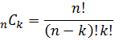 . Where n is the number of Order and k is number of cluster.

* -Second, begin the K-medoids algorithm to cluster order into K group and find best medoids.

#### Complexity

In total, complexity of this algorithm is **O(n^2)**

* n: number of point.

#### Flowchart

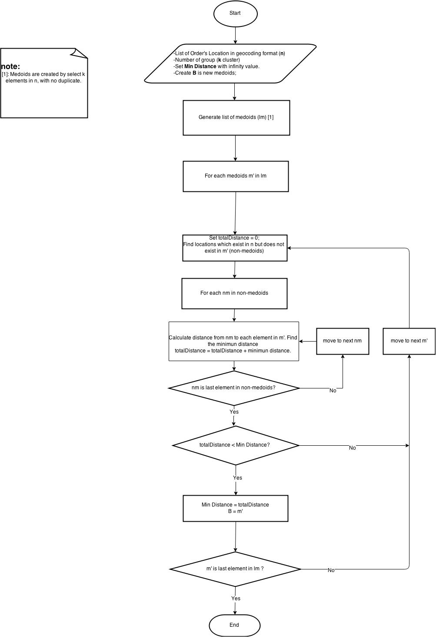

### Create a printable order

#### Definition Problem

Mini Bluetooth printer that we using only support print non-unicode text and image, with image it must be decode using manufacturer library before you want to print it. So if we want to print order in excel format we need to find a way to convert it to a format which printer can understand.

#### Solution

To achieve the goal above, I’m using some helper class from **Apache POI** to convert excel file an html file then use another library called **Html2Image** to convert a Html file to image, and now every become esier than before.

#### Flowchart

